Section 12 r/s in hibernate

Section 13 many to many association

Section 14 one to one mapping

Section 15 hibernate caching mechanism

Section 16 transaction management

Section 17 save and retrieve file

Section 18 calling stored procedure

Section 19 end to end mini project

Section 20 composite primary keys

Section 21 clinical data collection and reporting

Section 22 deploy to aws

Section 23 dockerize the clinical app

Section 24 connecting to multiple databases

Section 25 E dating one more usecase

Section 12 r/s in hibernate

**Introduction**

**Objective**

What JPA association mapping is

We don’t put all data in one table

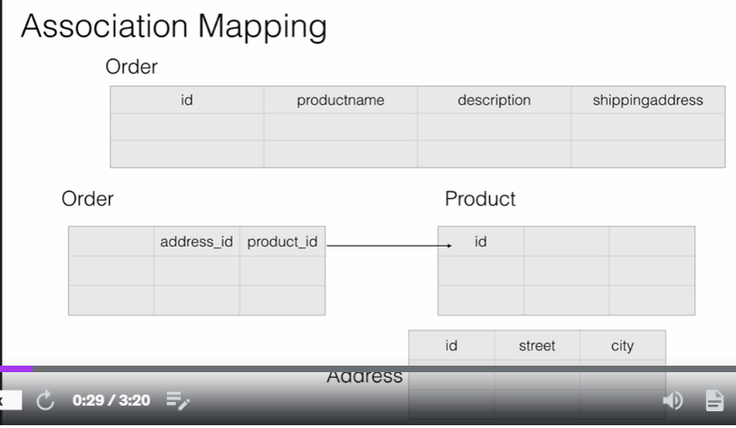

Behind the scene all joins query will be generated by JPA

**NOTE**

Jpa support four type of association

**One to one**

**A person have one license**

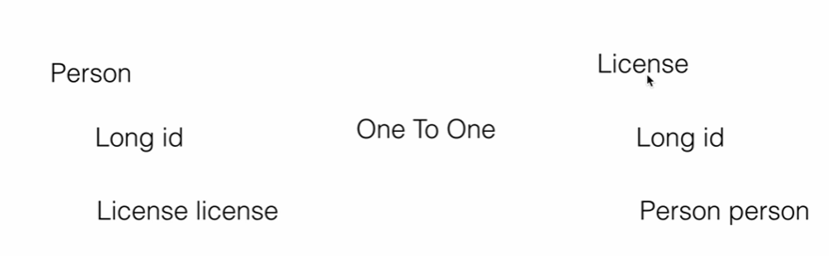

**Many to many :**

An order can have multiple product and a product can belong to multiple order

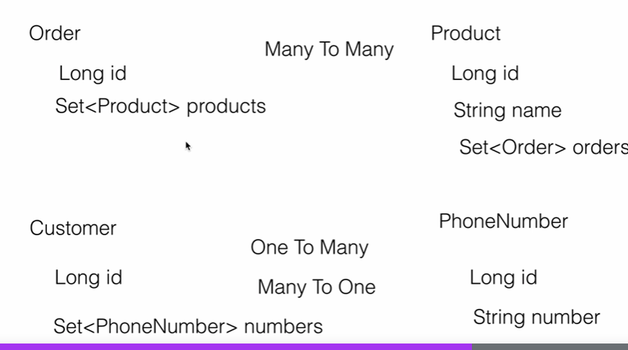

**One to many and many to one**

From customer perspective : one to many

From phone number perspective : many to one

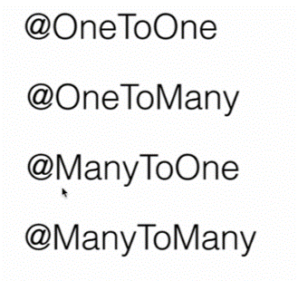

**One to Many Association**

An object of one entity is associated with multiple object of another entity

**Example**

a client entity can have multiple phone number and many phone number belong to one client

**Note:**

We usually called client as parent and phone number as child

This is bidirectional association

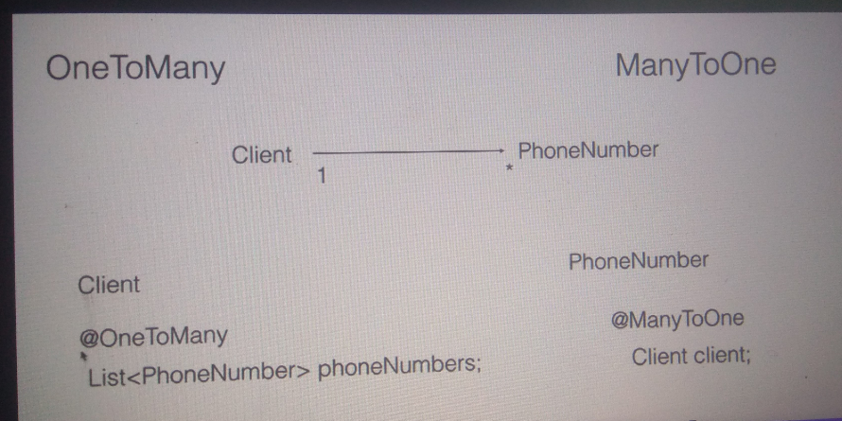

**Create the d/b schema**

use mydb;

create table customer(

id int PRIMARY KEY AUTO_INCREMENT,

name varchar(20)

);

create table phone_number(

id int PIRMARY KEY AUTO_INCREMENT,

customer_id int,

number varchar(20),

type varchar(20),

FOREIGN KEY (customer_id)

REFERENCES customer(id)

)

select * from customer

select * from phone_number

**Note :**

Type represent what type of phone number it is ( cell number or phone number)

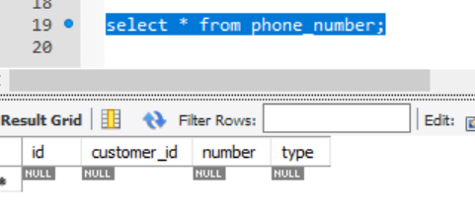

**Create the project**

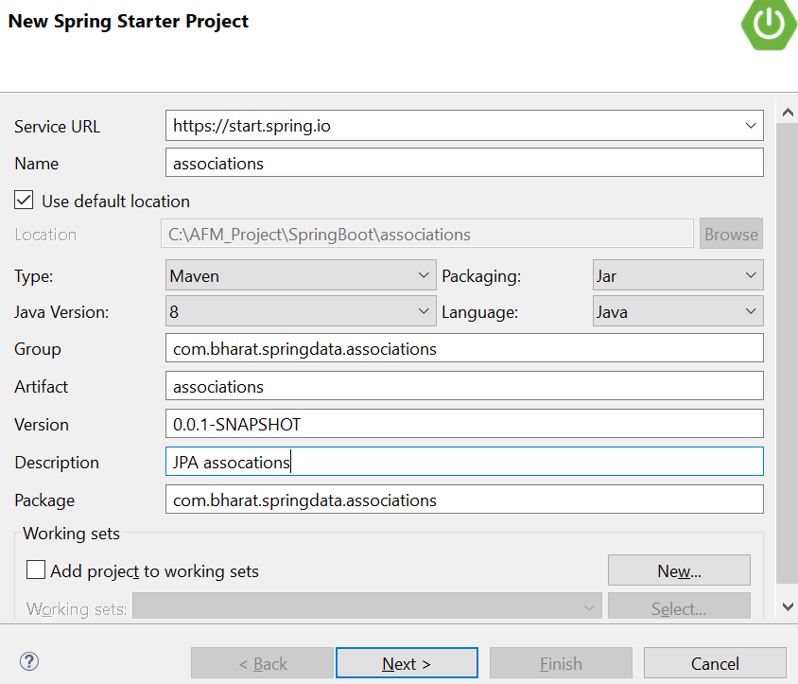

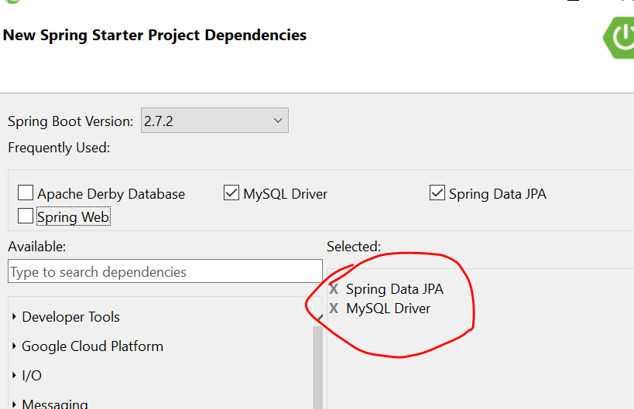

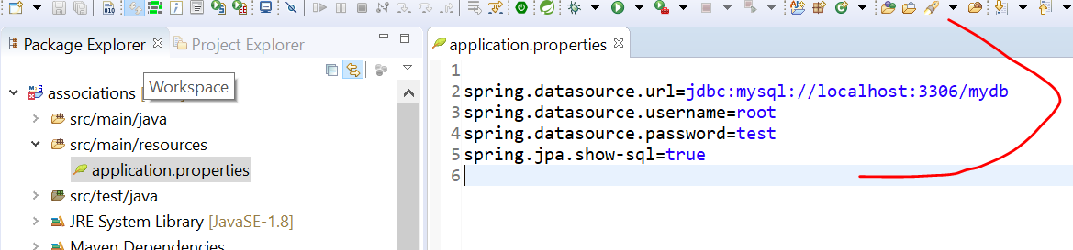

**Create Entities**

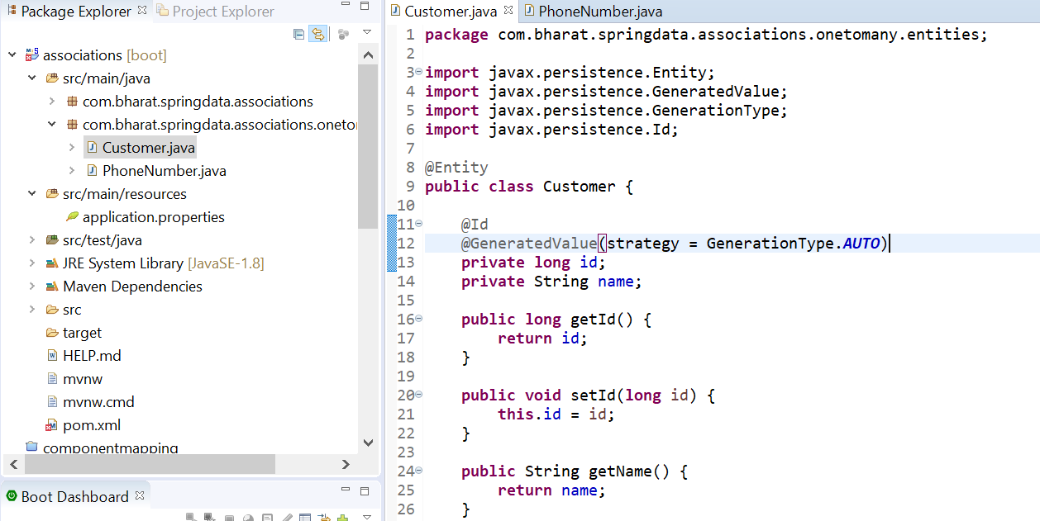

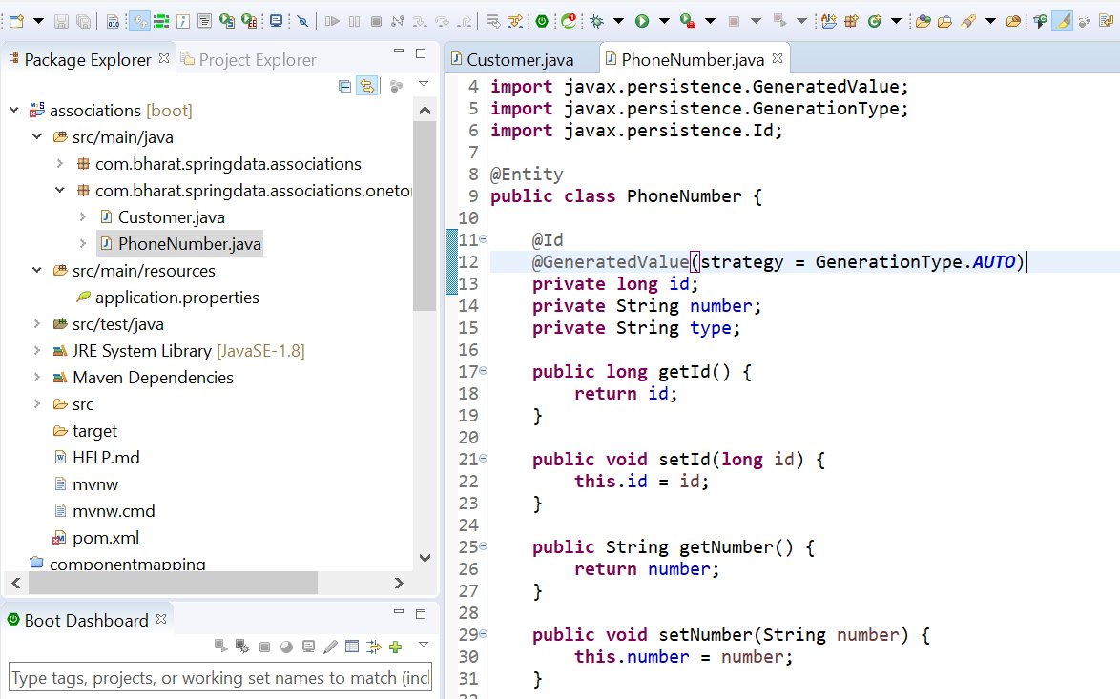

**Note :**

Association is yet need to be happen

**Using @OneToMany**

**Between customer and phone number**

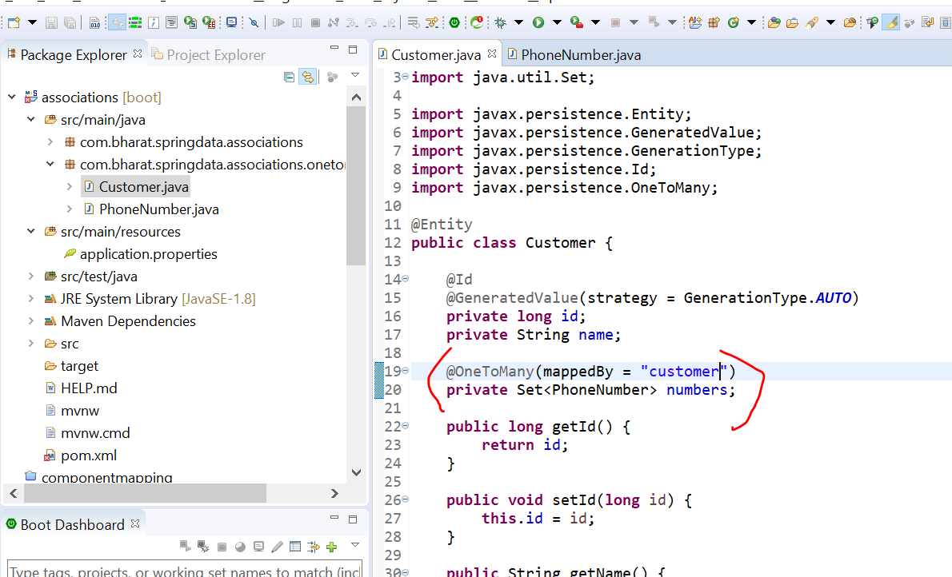

**mappedBy :** this tell us primary key is in customer and it owns the mapping

We successfully mapped customer to the phone number

**Using @ManyToOne**

**@JoinColumn :** which tell hibernate which column in the phone number table should be use or associated with a particular customer

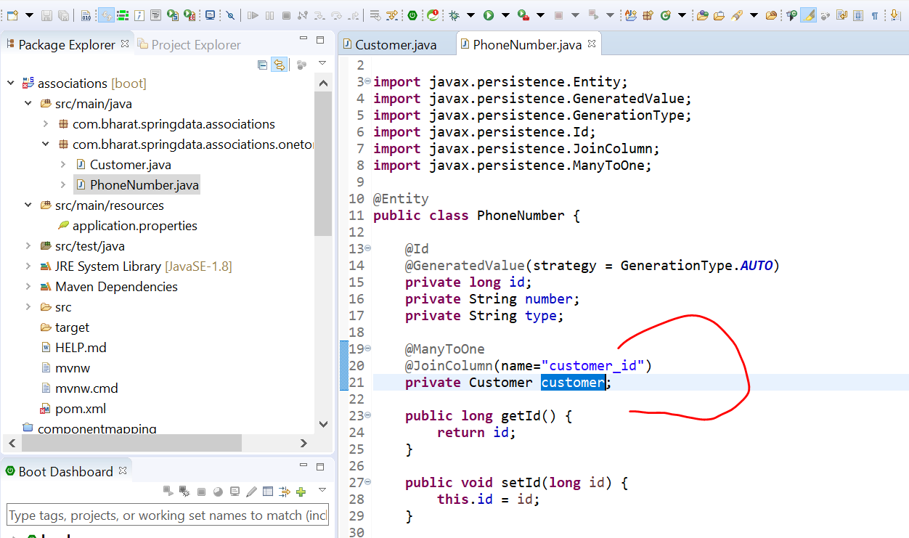

**Create the repository**

Create the customer repository so that we can perform various crud operation on customer as well as phone number table

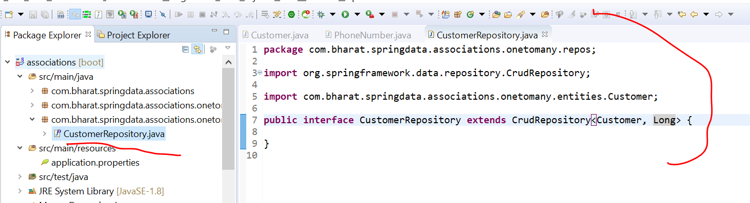

**Create and run the test**

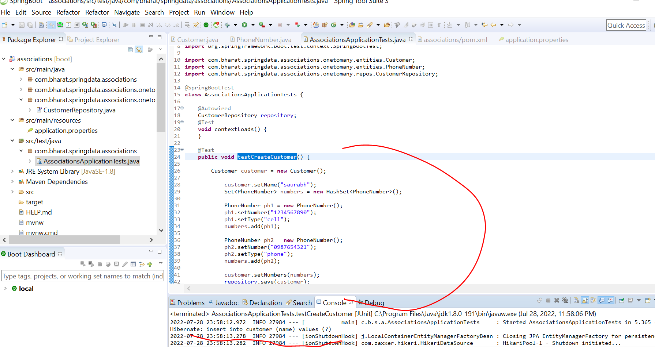

**Note:**

Insert statement only in customer will occur since we didn’t tell hibernate to save the phone number also.

To occur this we need to enable cascading

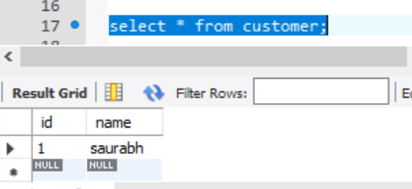

**Enable cascading**

In previous lecture customer get saved but associated object which is phone number didn’t saved

What is Cascade in JPA?

The cascade persist is **used to specify that if an entity is persisted then all its associated child entities will also be persisted**.

Let enable cascade in customer

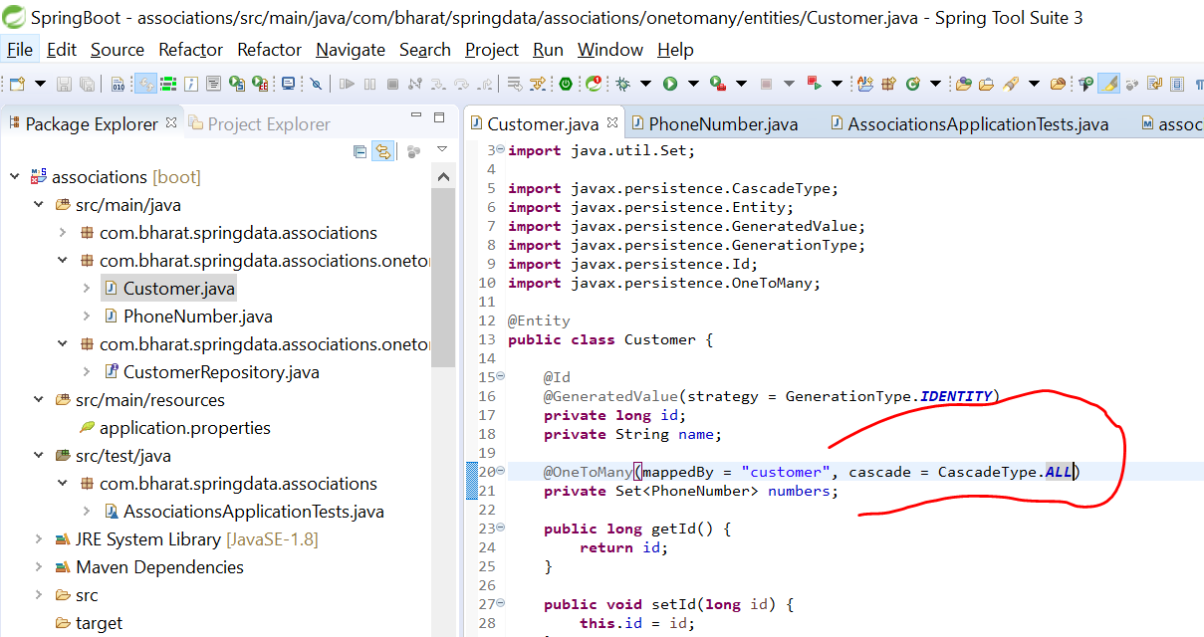

**Rerun the test case**

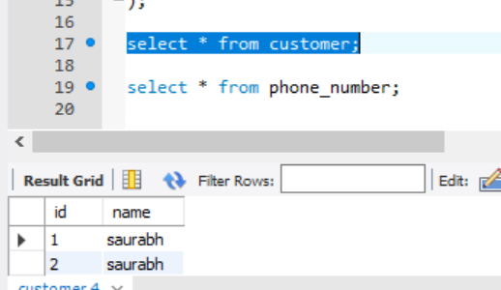

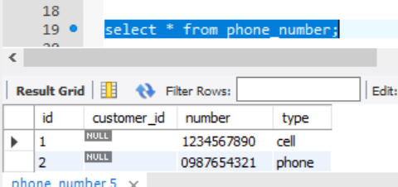

**Note** : the foreign key column is still null

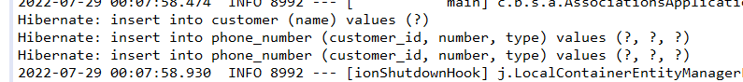

Three query will run

**Cascading**

Cascading is the process of propagating the non select operation like insert, select ,delete from the main object in association

To the child object

**Cascade="persist"**

An insert operation on main operation should be propagated to the child object

**Cascade="merge"**

An insert or update operation on main operation should be propagated to the child object

**Cascade="remove"**

If we delete the main object automatically the child object should also be delete

**Cascade="refresh"**

If we refresh the main object automatically the child object should also be refresh

**Cascade="detach"**

If we detach the parent object using entity manager the child object will be detached automatically

**Cascade="all"**

It will work for all above

Note: all these can apply to association

**Saving the foreign key**

There are two ways

**First way : to set the customer**

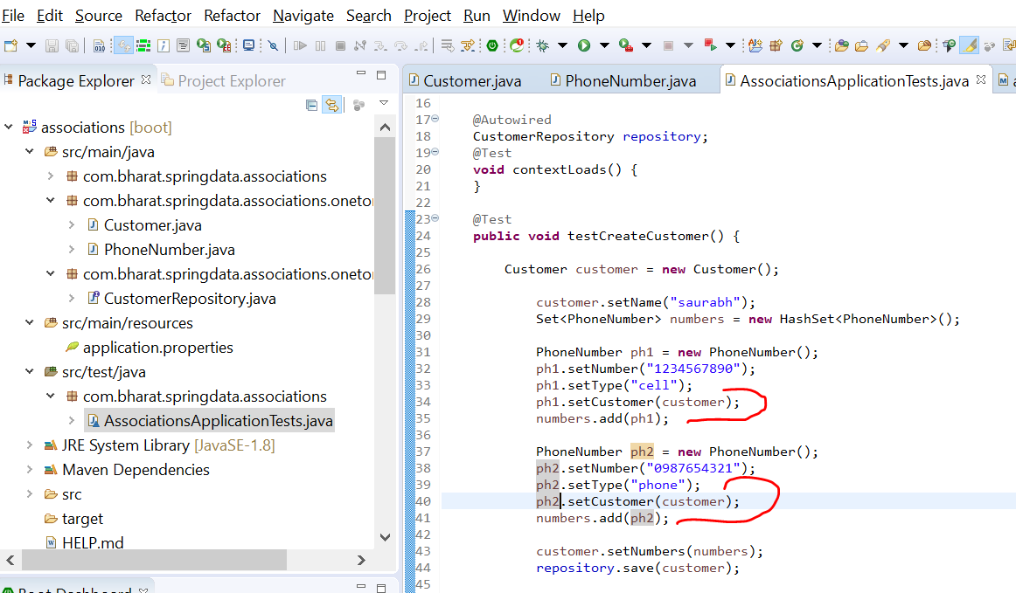

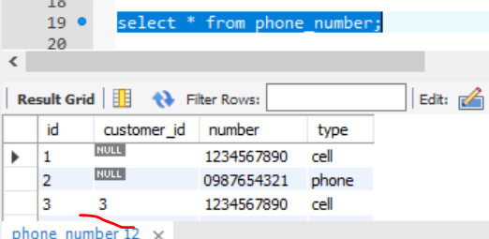

**Better way of handling the foreign key**

Instead of asking user to add customer we can add a method in entity to add customer which is cleaner way of doing it

**Add a new method in the customer entity**

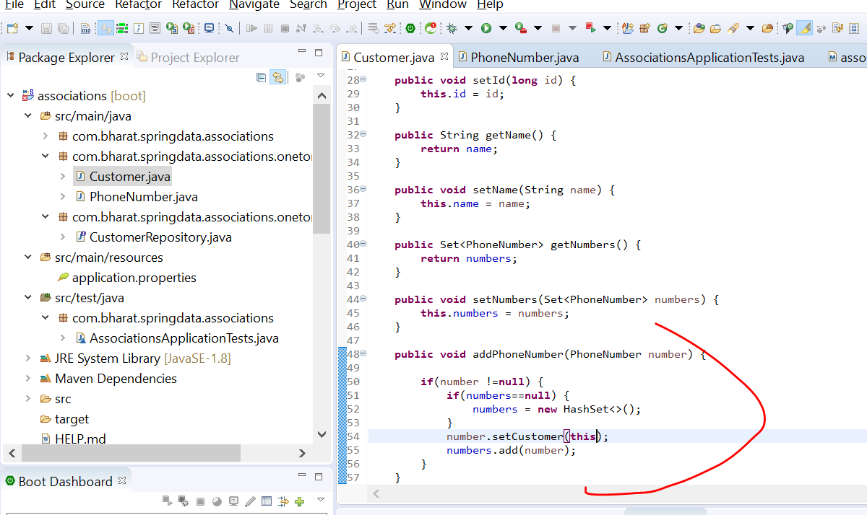

**Note :**

On whichever customer object this method is invoked we are setting the object to customer

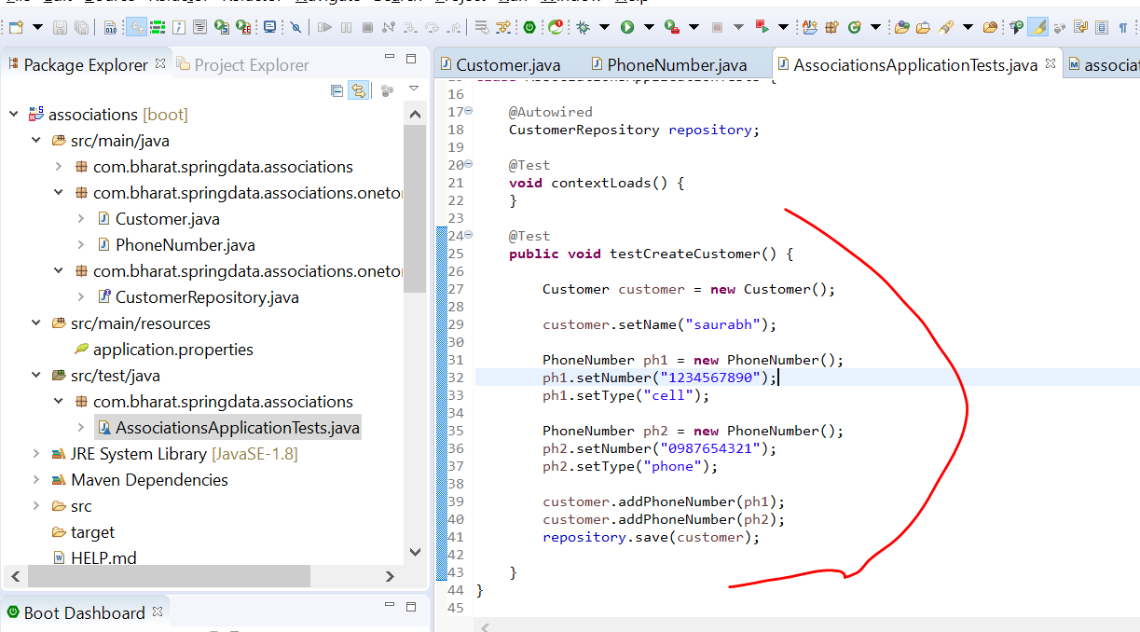

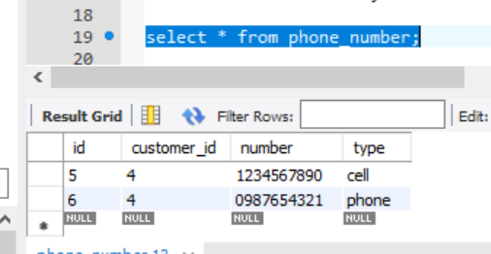

**Read**

**Will load a object :**

Onetomany

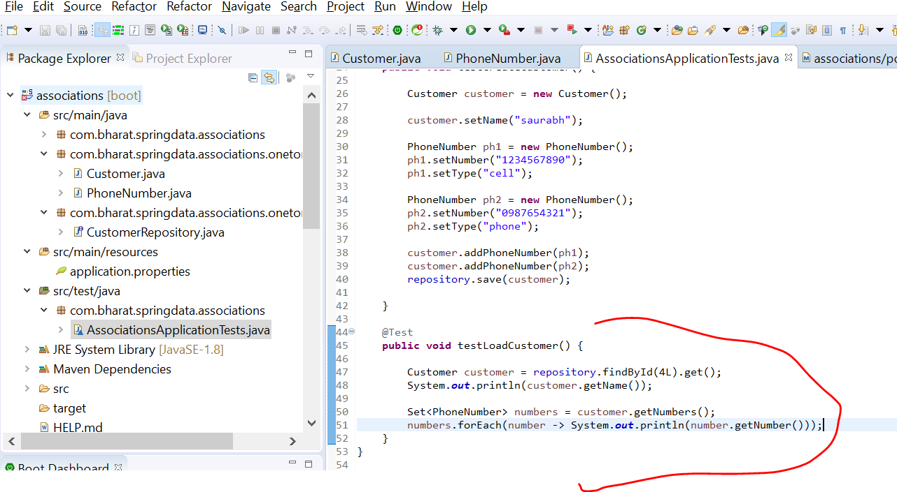

Note :

When we run a test case we are getting a lazy initialization exception

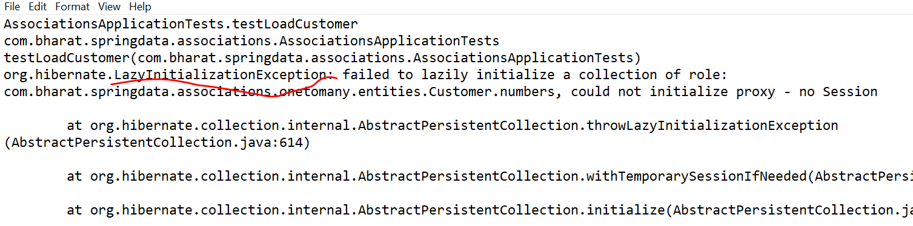

**what is lazy loading**

What is lazy loading exception?

Lazy Loading means that **the object won't be loaded to the Session context until it is accessed in code**. Hibernate creates a dynamic Proxy Object subclass that will hit the database only when we first use the object

When object is associated with other object and when parent object is loaded the child object can be loaded immediately which is **eager loading.**

**Or**

They(child object) can be fetch on demand basic which is known **as lazy loading**

**Note :**

If it lazy loading only the person object will be fetch from d/b and list of phone number will not be fetch from d/b

**But if we invoke getPhoneNumber :** then it will get all phone that is lazy loading or on demand fetching

Lazy loading where the data in the association is fetch on demand.

This will improve performance since it will not fetch all unless it is required.

So when parent object is loaded it is not loaded right away

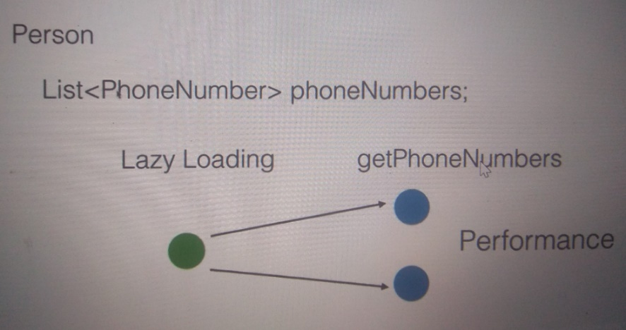

Note : to enable :

Eager will fetch right away as soon as parent object is loaded child is also get loaded

Lazy: it will only fetch when the child object is accessed first time in the application

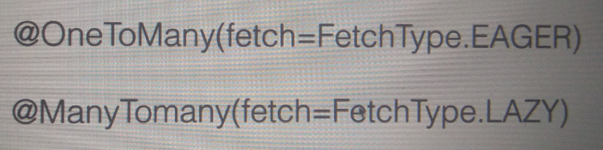

What is difference between lazy loading and eager loading in hibernate?

Eager Loading is a design pattern in which data initialization occurs on the spot. Lazy Loading is a design pattern that we use to defer initialization of an object as long as it's possible.

**Eager Fetch**

**By default :**  customer info is loaded lazily

To make the customer info loaded eagerly

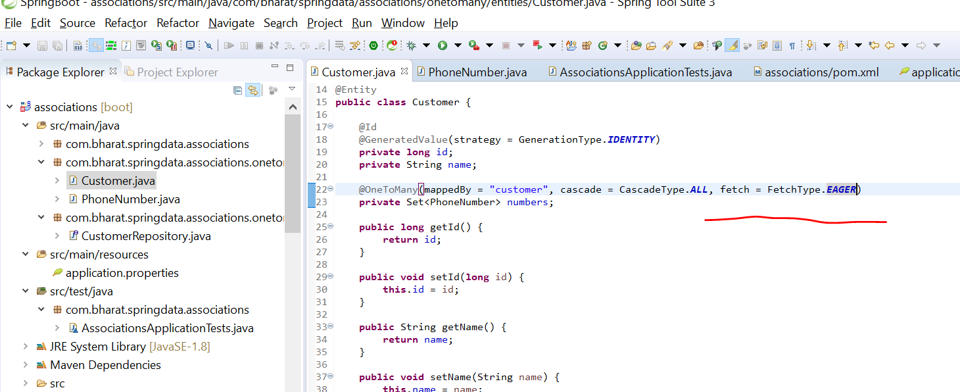

**Rerun test load customer**

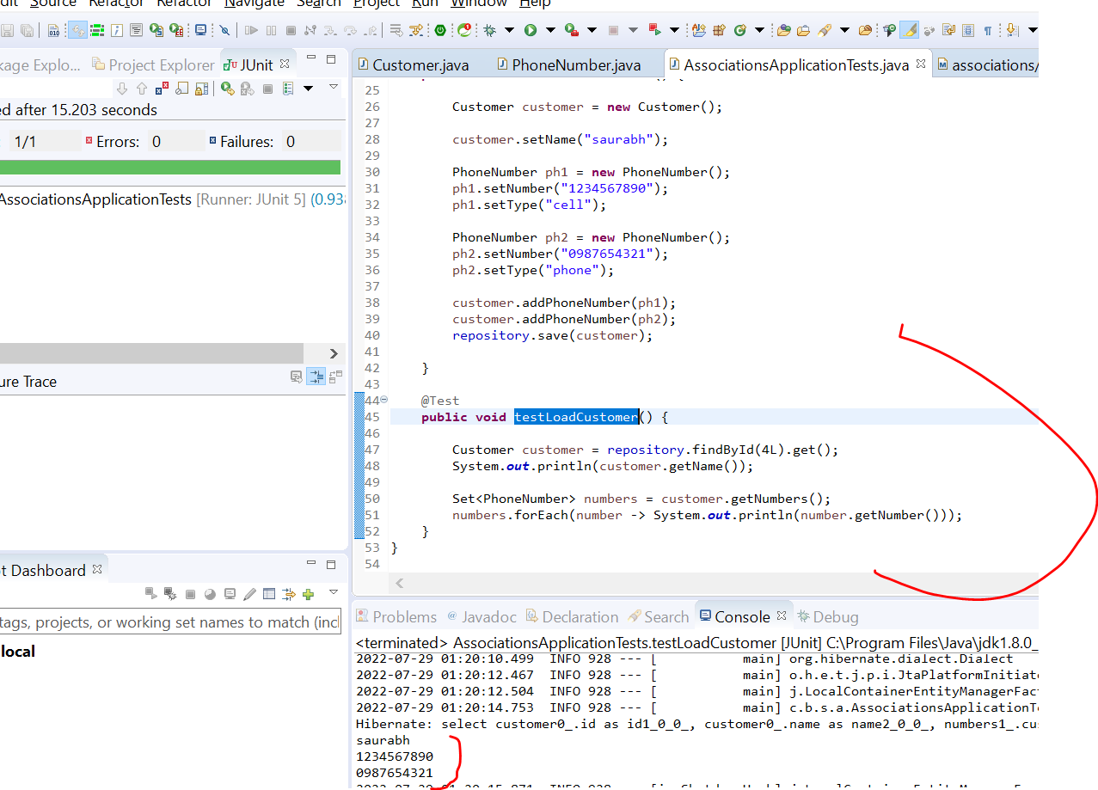

Now it is showing customer name as well as phone number

**Lazy Fetch**

Once we enable eager the customer info as well as phone number is loaded right away when we access the customer

Here notice one select query will execute

**But we want lazy loading to work**

Remove eager by default it will be lazy loading

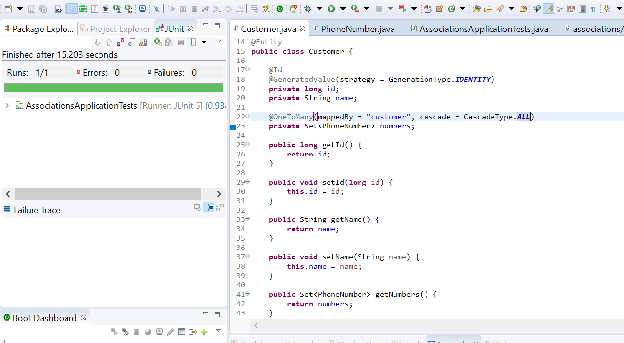

Mark the test case with **@Transactional** that is required for lazy loading to work

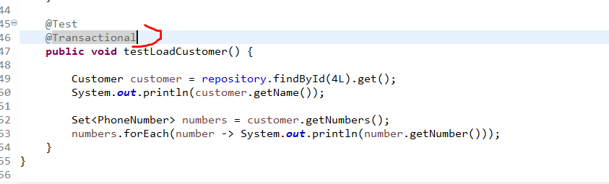

Note:

Eager : only one select query run and fetch all info

Lazy : two select query execute only when we call it will fetch info.

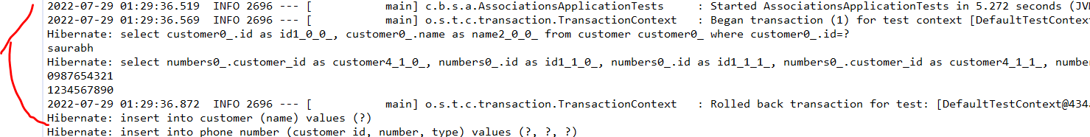

**Update**

**Change to eager**

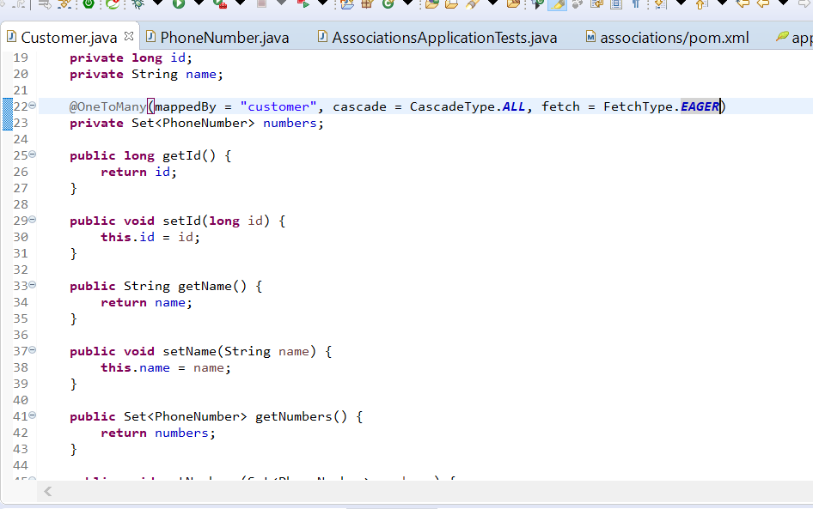

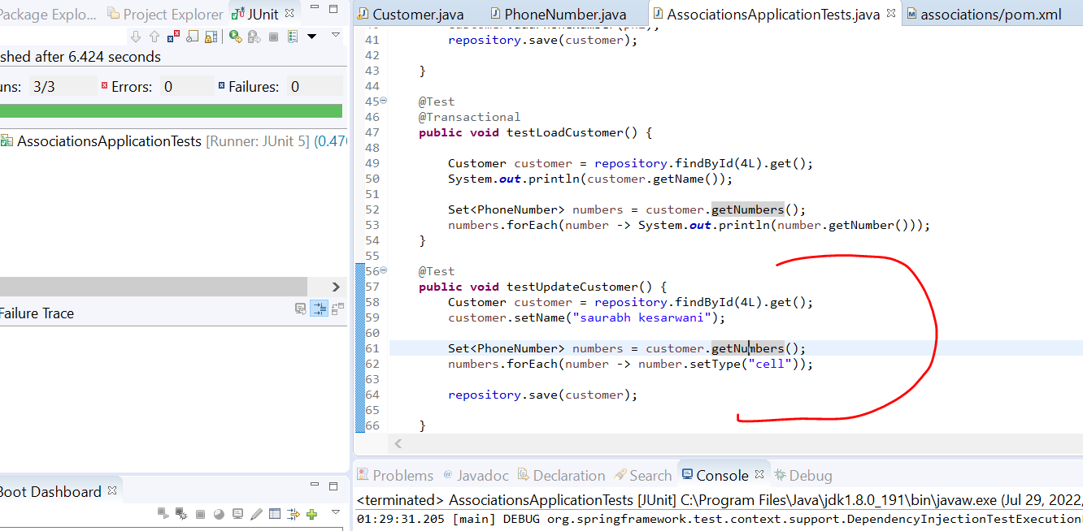

**Note :**

**It will fire**  only one update query since one column is already having cell while running testUpdateCustomer



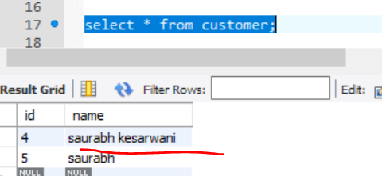

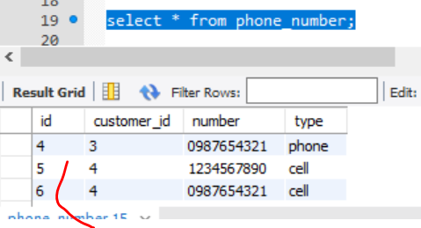

We did not save the phone number separately when we save customer automatically everything will get saved

**Delete**

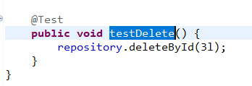

It will first delete from child table the another delete on customer

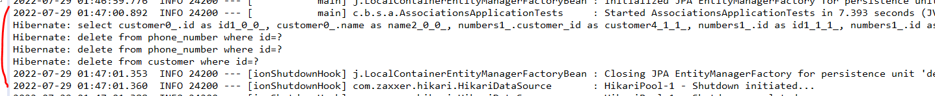

Section 13 many to many association

**Example**

A patient can go to multiple doctor and a doctor can treat multiple patient

A programmer can work with multiple project and a project assigned with multiple programmer

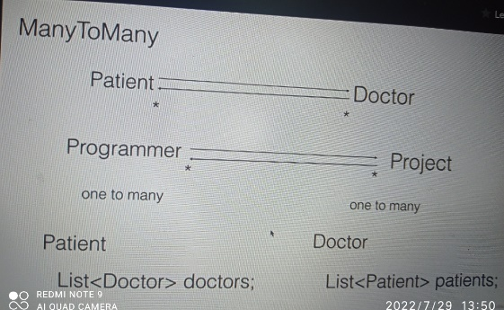

Note :

In d/ b we have three table , entity table and another table for mapping between those entity.

Mapping table will have the primary key of both entity table

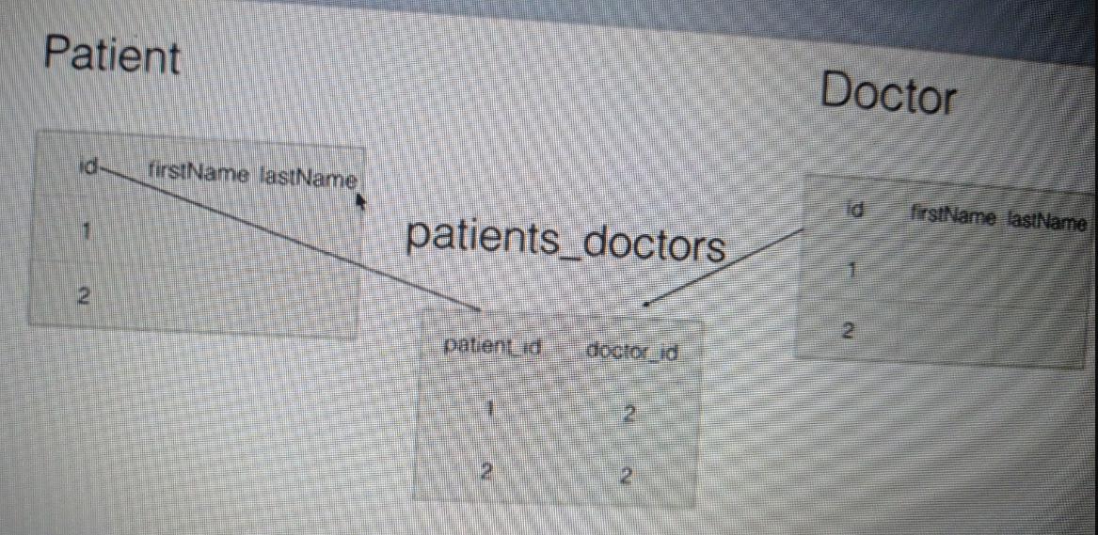

Note :

Lazy loading and cascading will be apply on many to many

**Create the tables**

use mydb

create table programmer(

id int PRIMARY KEY AUTO_INCREMENT,

name varchar(20),

salary int

)

create table project(

id int PRIMARY KEY AUTO_INCREMENT,

name varchar(20)

)

create table programmers_projects(

programmer_id int,

project_id int,

FOREIGN KEY (programmer_id)

REFERENCES programmer(id),

FOREIGN KEY (project_id)

REFERENCES project(id)

)

select * from programmer

select * from project

select * from programmers_projects

**Create entities**

Will use same association project

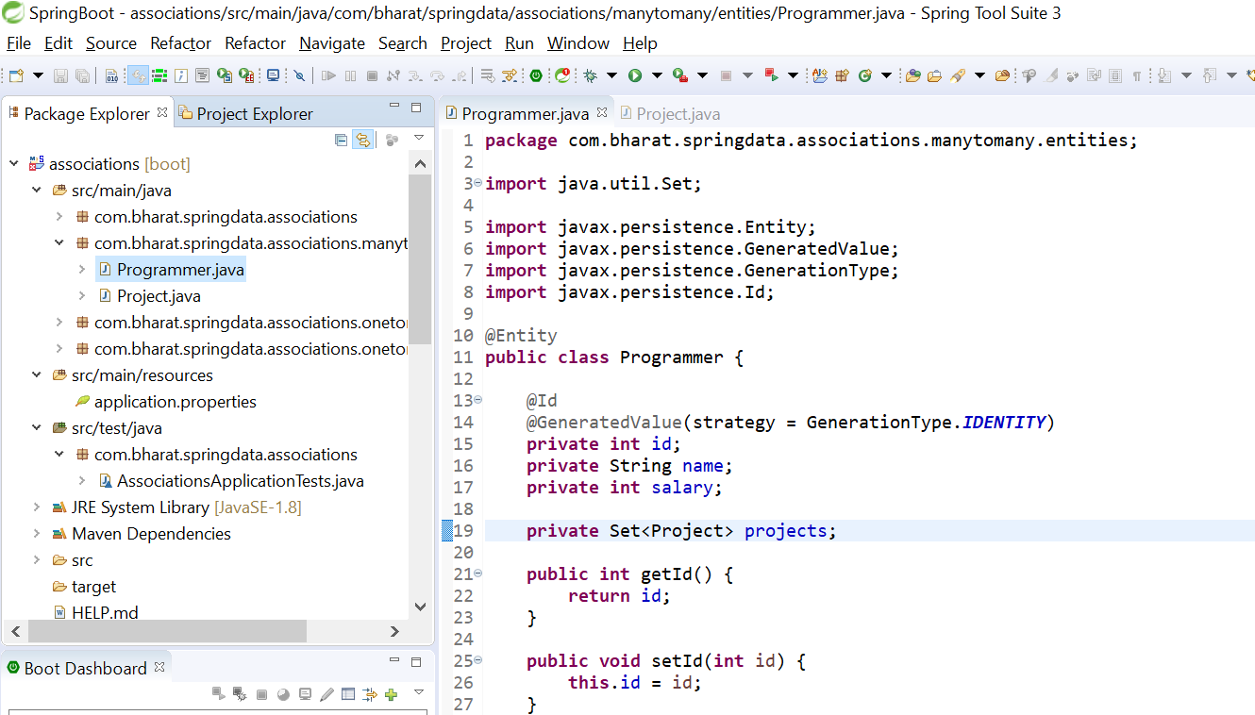

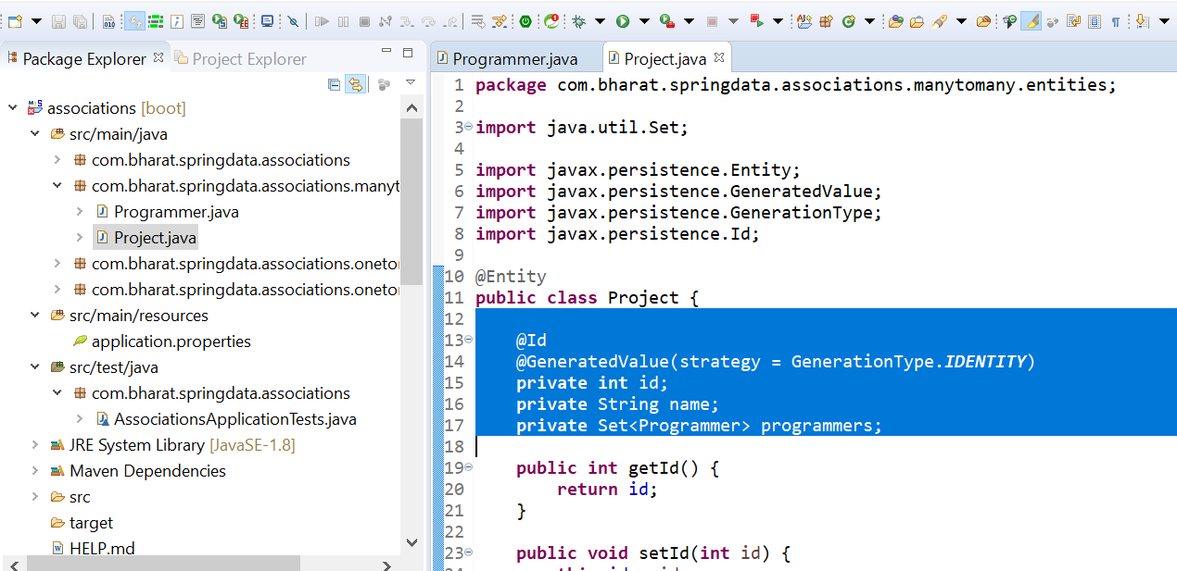

**Use the many to many mapping**

**joinTable :** will tell this is the join table and what are the keys is associated

**Cascade :**

When we save programmer then project will also saved

**Note** : inverseJoinColumn is the other side of R/S from the project side

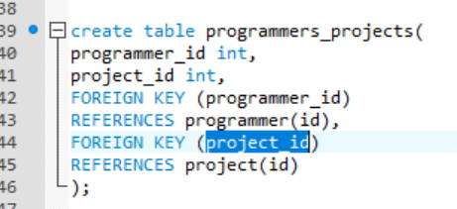

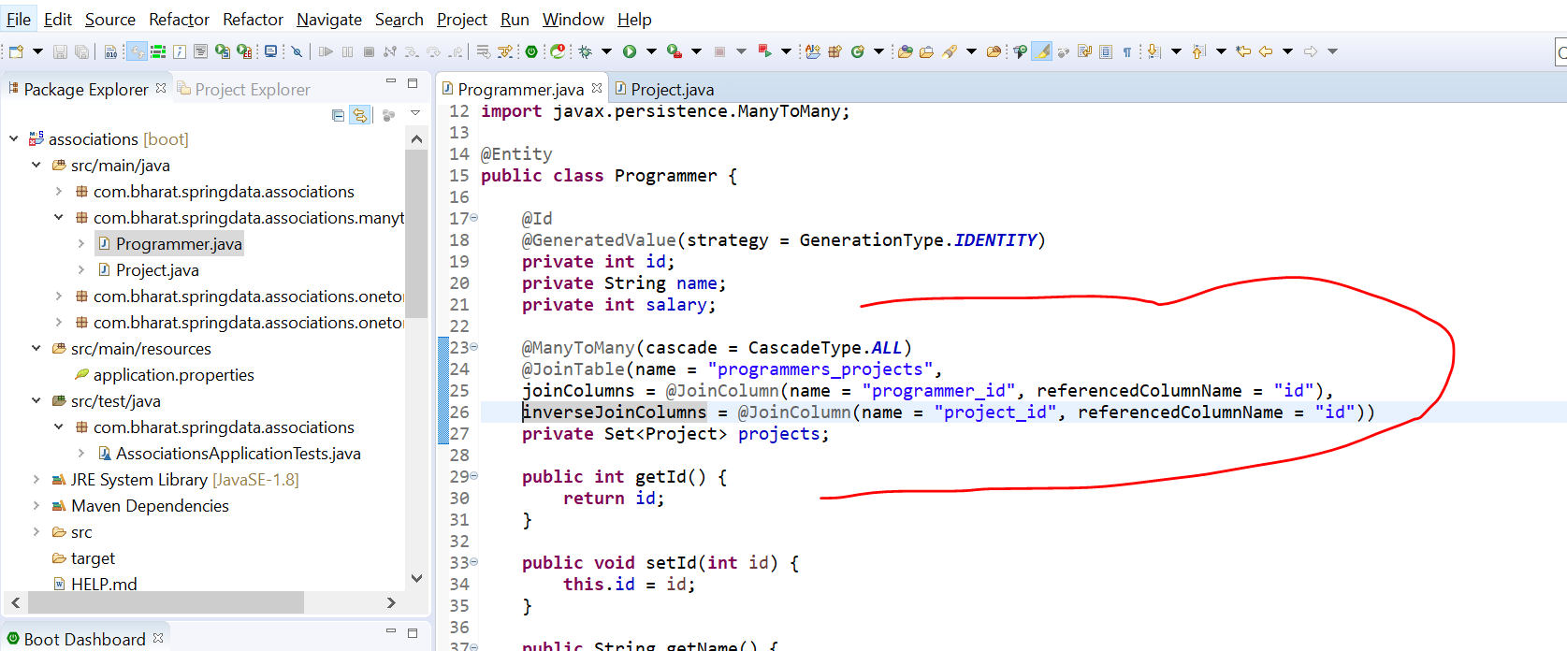

**Handle the other side of r/s**

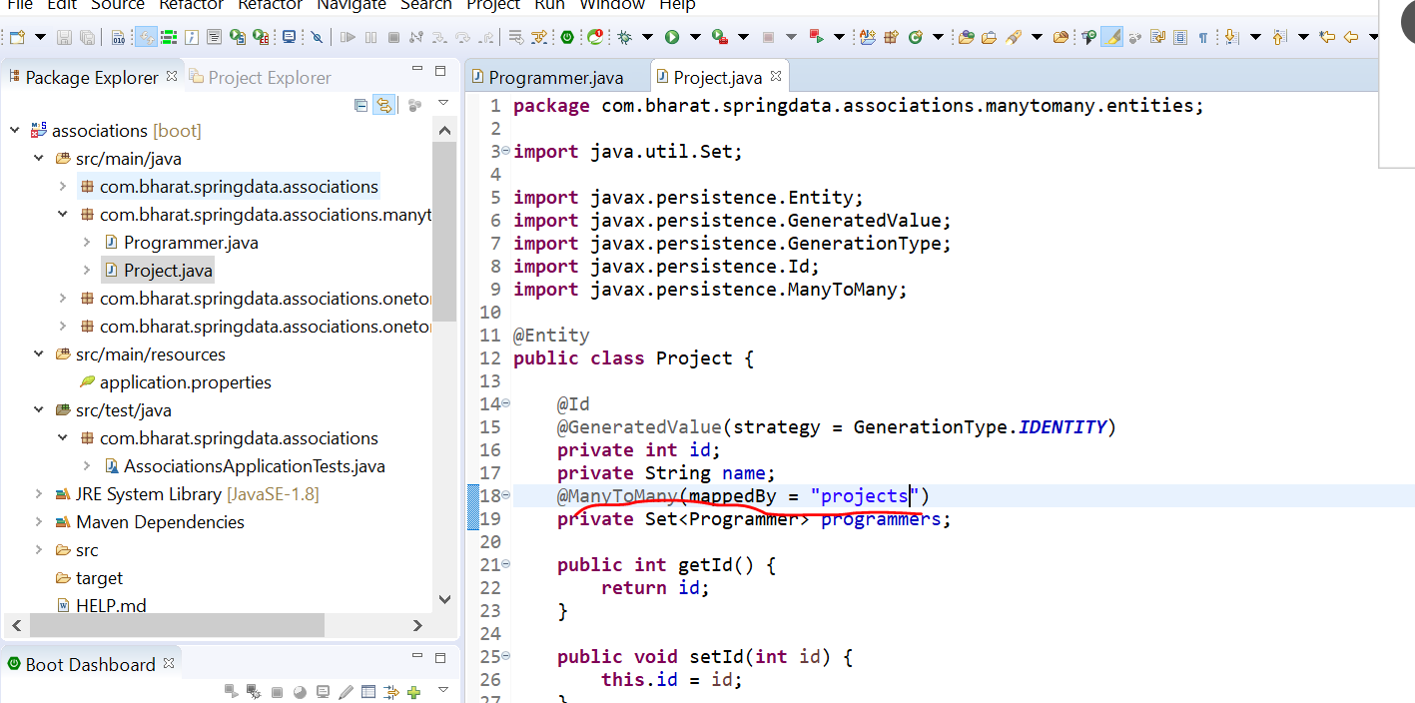

**Projects will write as plural**

**mappedBy**  define this is the inverse of r/s which is already defined inside this entity programmer

**What is mappedBy in JPA?**

The purpose of the MappedBy parameter is to instruct JPA: Do NOT create another join table as the relationship is already being mapped by the opposite entity of this relationship.

**Create the repository**

**Will create programmer repository so that**  we can perform crud operation on programmer as well as project

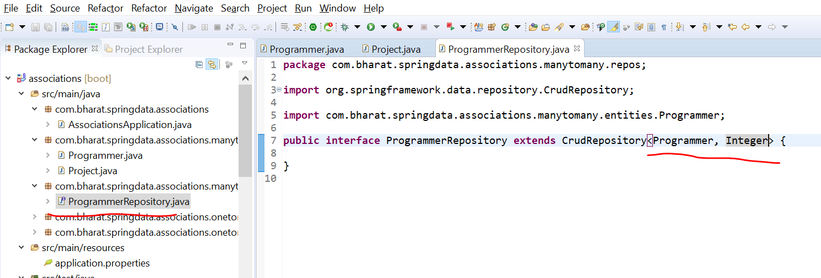

**Test create**

**To save p**rogrammer and it project

Note :

While saving three query will run

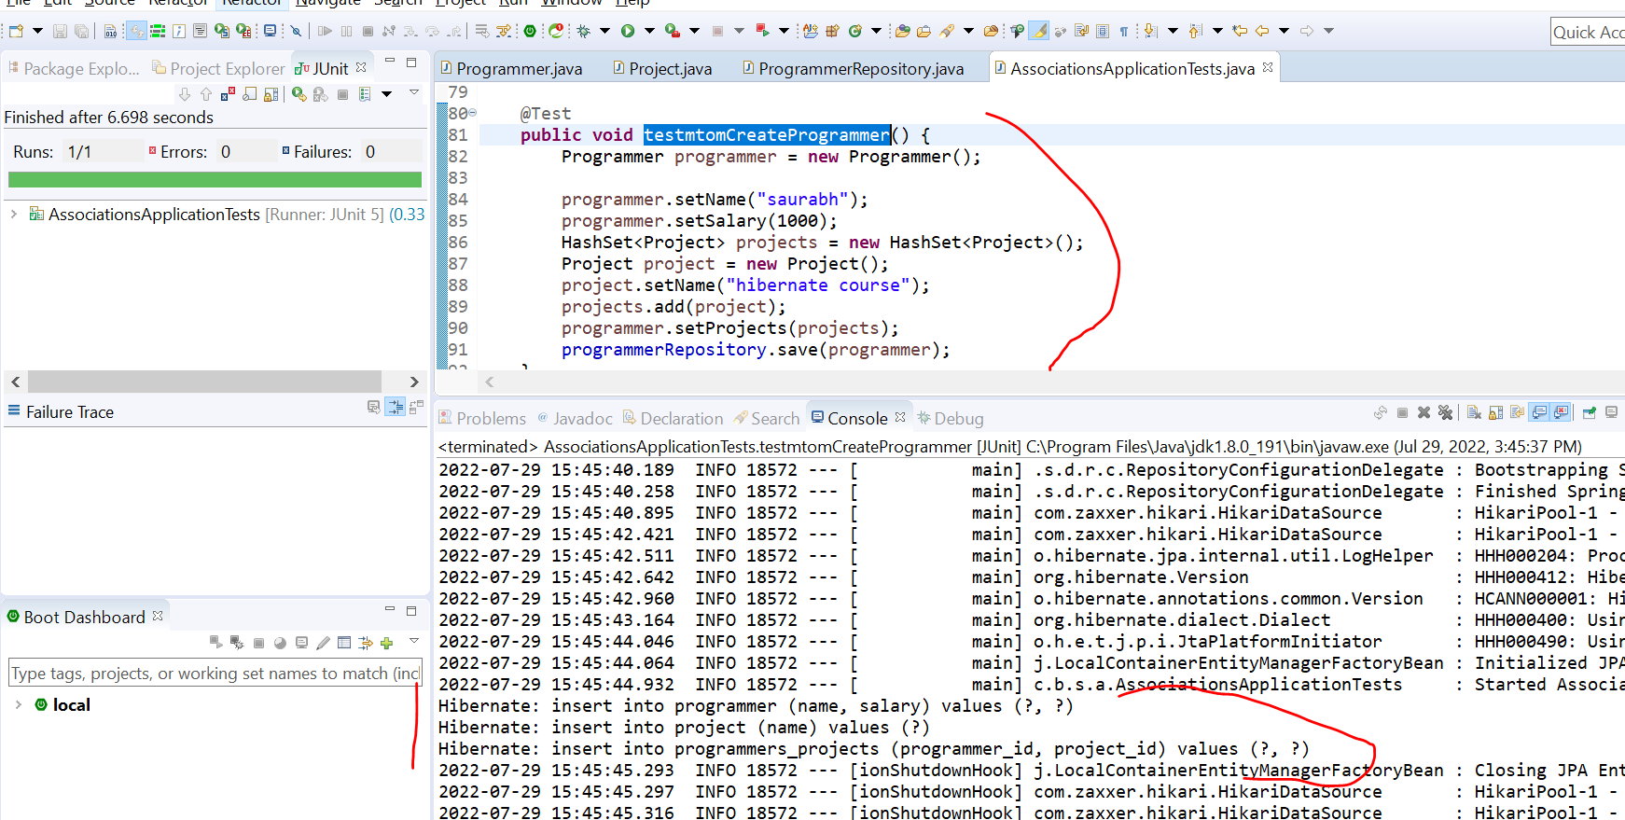

**Load**

**Objective :**

To load a programmer and project back from database

Create toString() in programmer and project

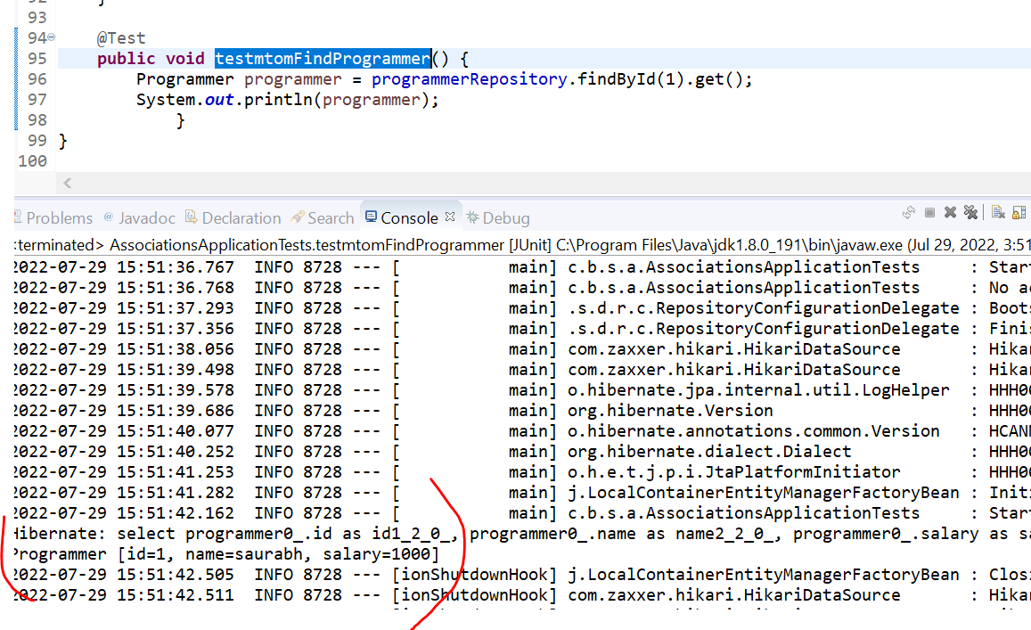

**Note :**

**It onl**y retrieving programmer details not retrieving project details

Because by default on ManyToMany association it is lazy loading

**Now two queries will get fire**

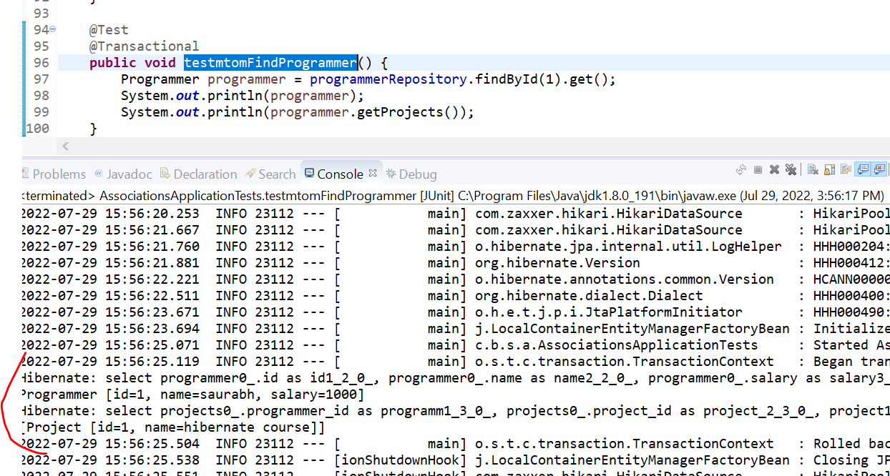

**Enable eager fetching**

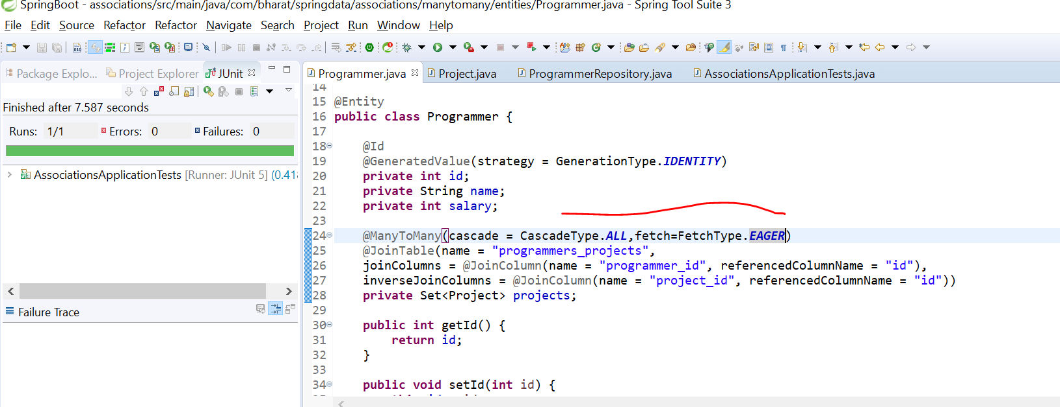

**Rerun test case :**

**Now on**ly one query will run:

If we done need project info use lazy info because it is good in performance

:select programmer0_.id as id1_2_0_, programmer0_.name as name2_2_0_, programmer0_.salary as salary3_2_0_, projects1_.programmer_id as programm1_3_1_, project2_.id as project_2_3_1_, project2_.id as id1_4_2_, project2_.name as name2_4_2_ from programmer programmer0_ left outer join programmers_projects projects1_ on programmer0_.id=projects1_.programmer_id left outer join project project2_ on projects1_.project_id=project2_.id where programmer0_.id=?

**Programmer [id=1, name=saurabh, salary=1000]**

**[Project [id=1, name=hibernate course]]**

Section 14 one to one mapping

Example :

A person will have only one driver license and driver license is associated with only person

Student will have only one libraryMembership and libraryMembership belong to only one student

There are two ways of using onetoone mapping

1. **Shared primary key concept** and this r/s is always bidirectional

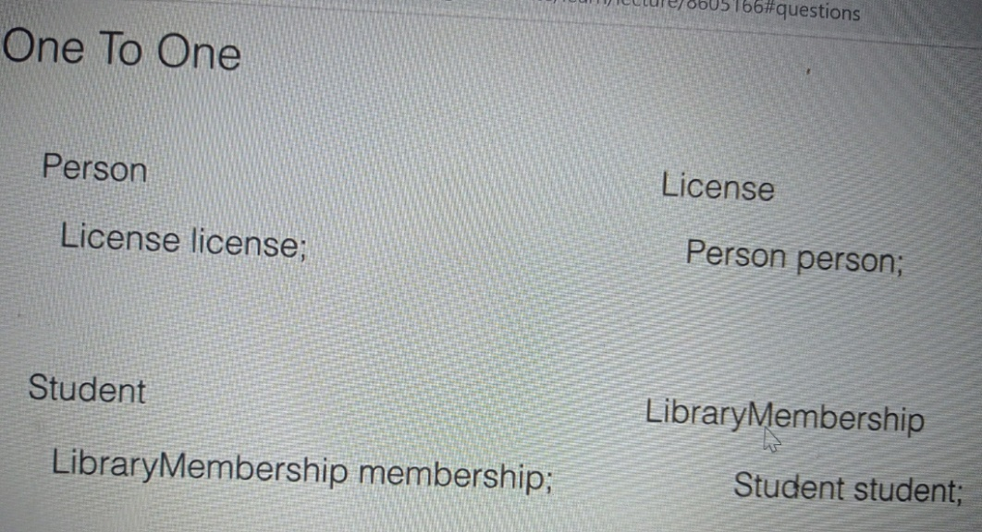

**Foreign key concept**

1. **It can be unidirectional** : a person will not have driving license but driving license is always associated with person

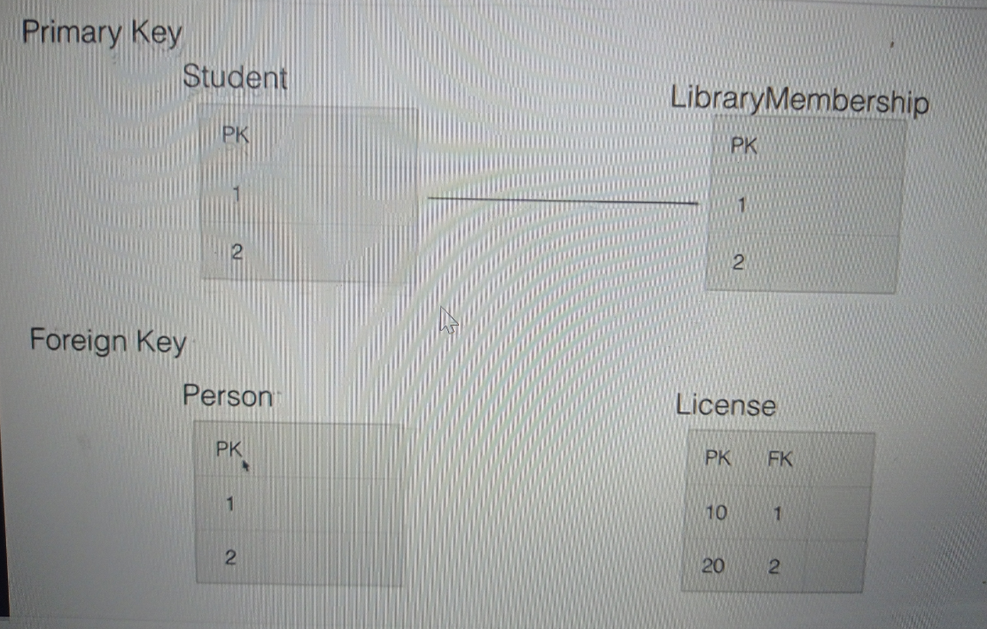

**Create the DB table**

use mydb

create table person(

id int PRIMARY KEY AUTO_INCREMENT,

first_name varchar(20),

last_name varchar(20),

age int

)

create table license(

id int PRIMARY KEY AUTO_INCREMENT,

type varchar(20),

valid_from date,

valid_to date,

person_id int,

FOREIGN KEY (person_id)

REFERENCES person(id)

)

select * from person

select * from license

**Create the entities**

**@Temporal Annotation in JPA**

* @Temporal annotation must be specified for persistent fields or properties of type java. ...
* In JPA, @Temporal annotation solves the one of the major issue of converting the date and time values from Java object to compatible database type and retrieving back to the application.

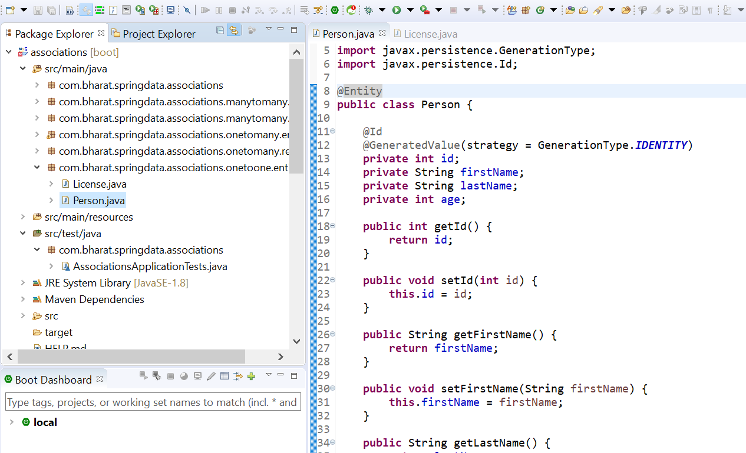

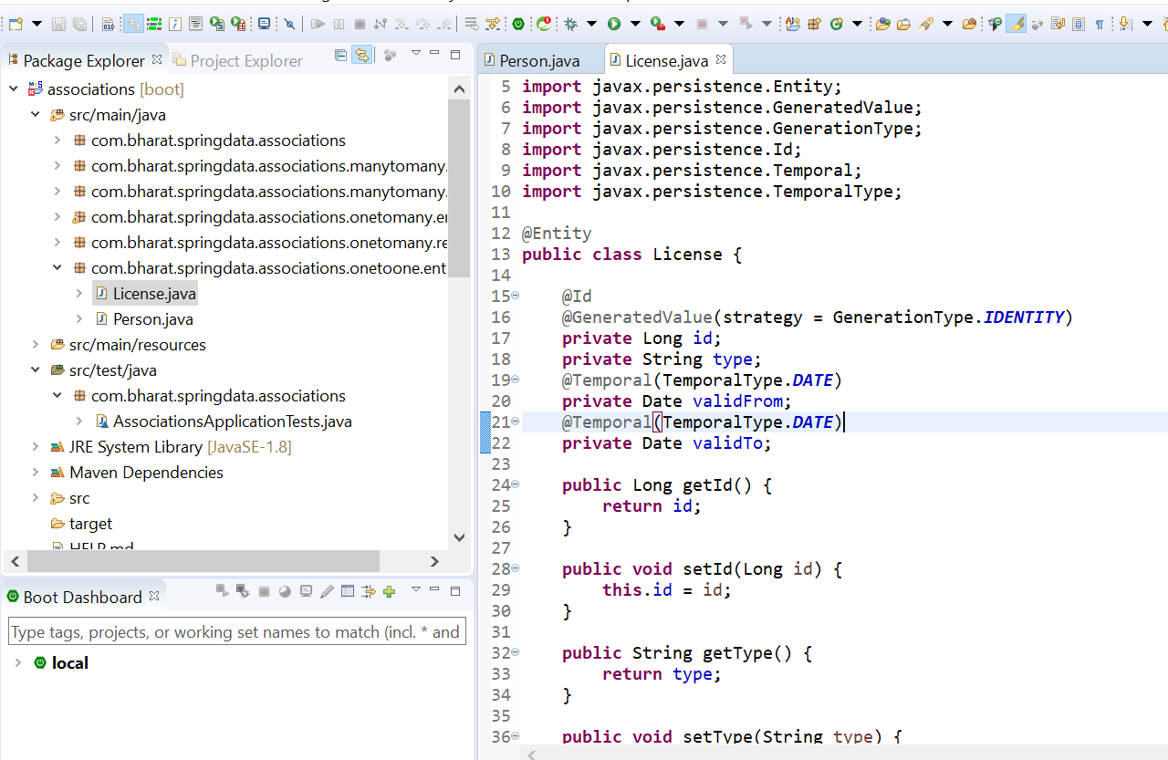

**Define the association**

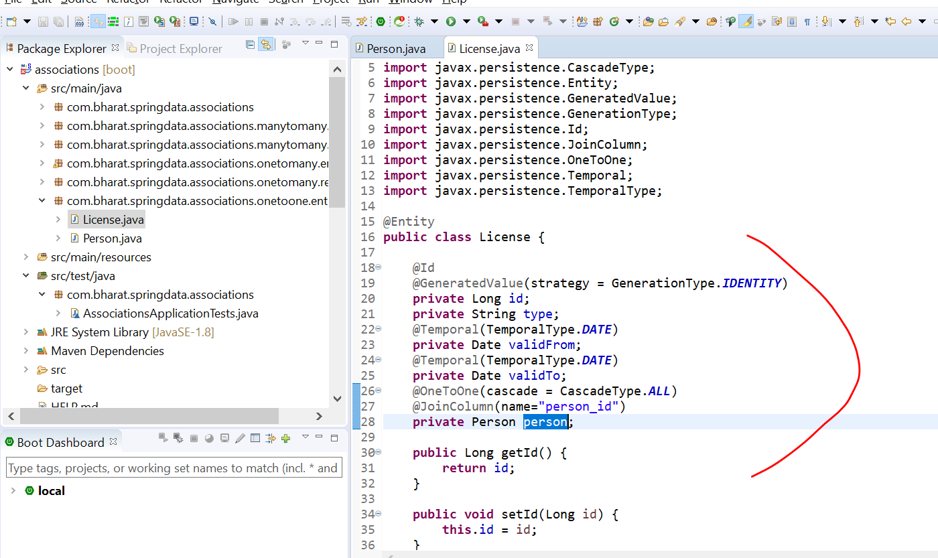

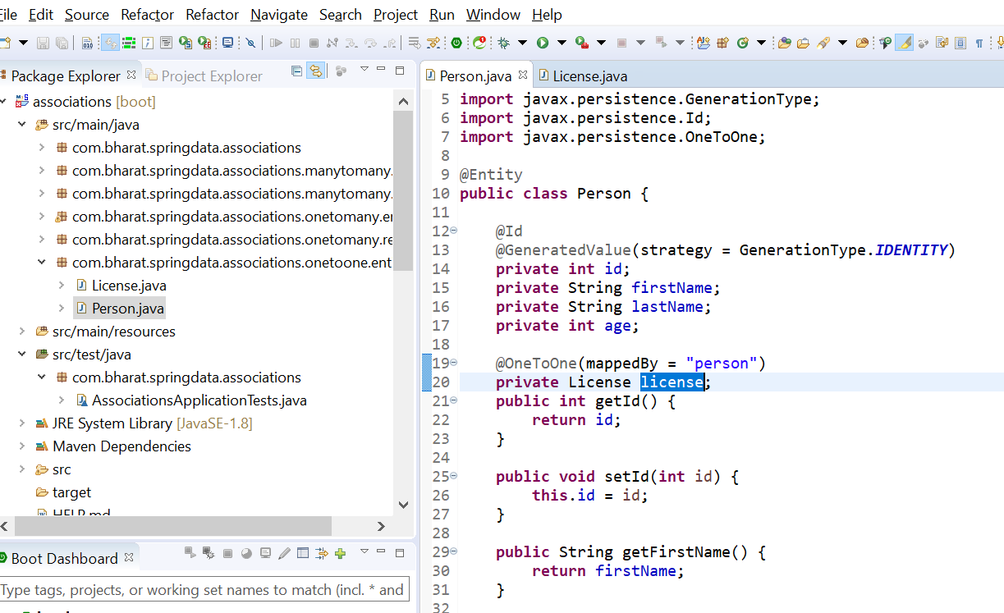

**Create the repository**

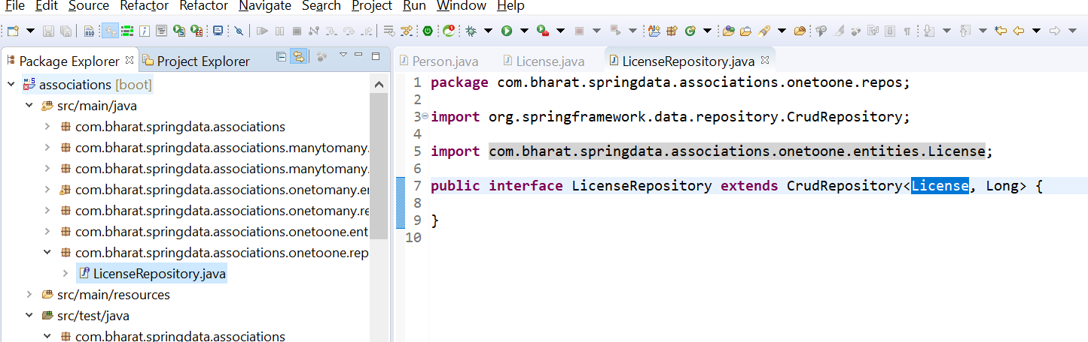

**Test OneToOne**

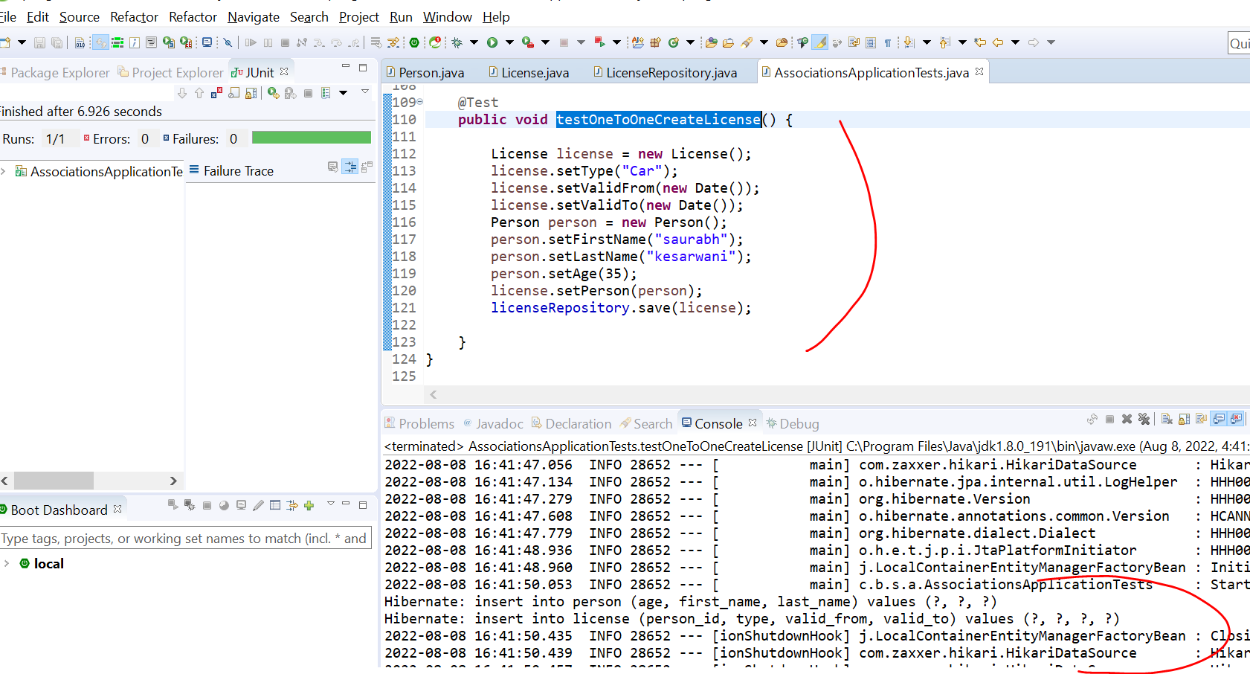

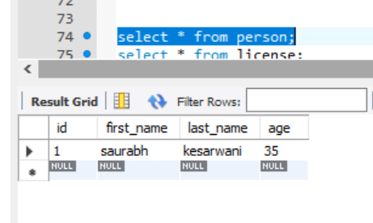

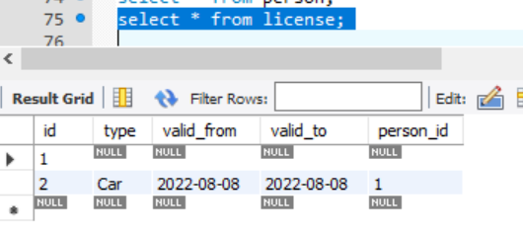

Section 15 hibernate caching mechanism

Introduction

**Caching is storing that data of an object in temporary location**

Very first time request come caching framework will read from the d/b and convert into object and store it to temporary memory location even it in disk

The next time request come this caching framework will check whether data exist in cache. The object process it and send it back to client

Improving the performance.

Cache will be refreshed everytime the object is updated in d/b automatically the hibernate f/w will refresh the cahce and if it is deleted,

It will be delete from the d/b. it will empty the cache by using **evict** method on hibernate session object

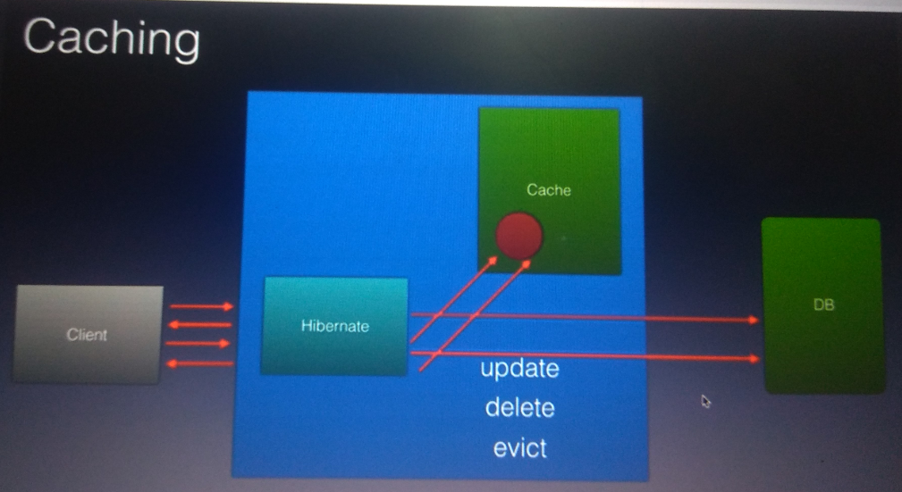

**Two level of cache**

Hibernate support caching a**t two level**

**Level 1 :** session

**Level 2 :** sessionFactory

By default level 1 cache is enabled

But we configure level 2

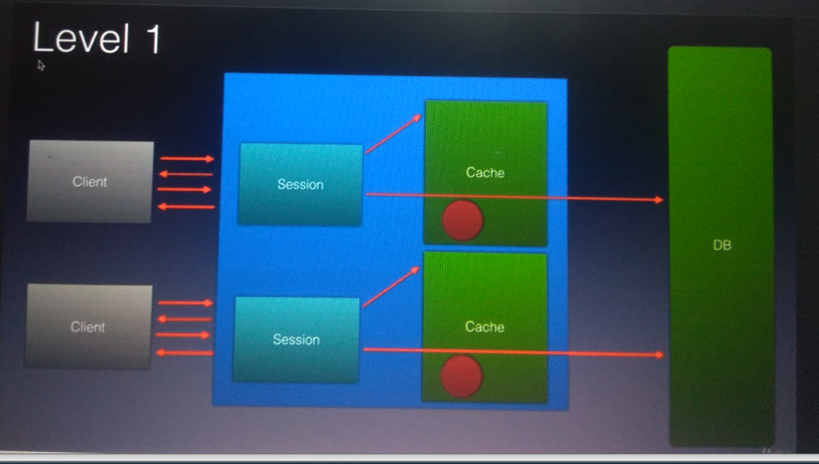

**sessionFactory** :

it is use to create multiple hibernate session

If we create a cache it will be shared across multiple session

**Level 2 cache example :**

Ehcache

swaram cache

Jboss tree cache

Os cache

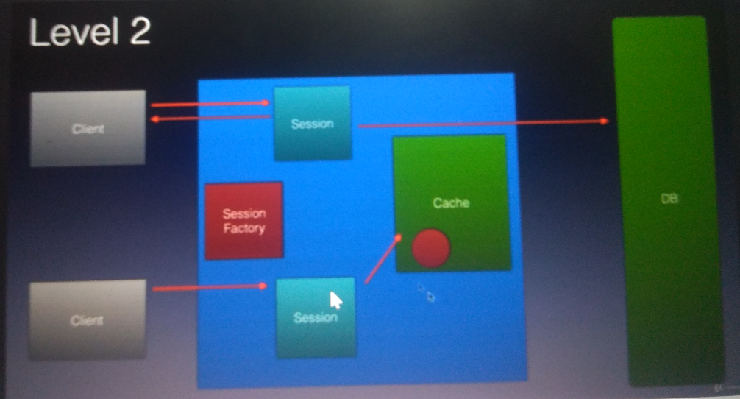

**First level cache in action**

**in order level 1 cache** need to work we need to mark it @Transactional

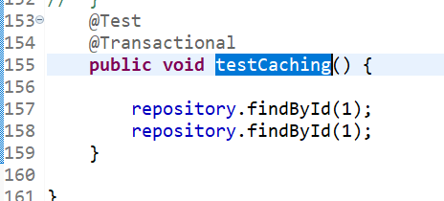

Although we are loading a product couple if time but select statement run only once



What is the use of @transactional in Hibernate?

A transaction simply **represents a unit of work**. In such case, if one step fails, the whole transaction fails (which is termed as atomicity). A transaction can be described by ACID properties (Atomicity, Consistency, Isolation and Durability).

**Evict the object from cache**

**Objective** : remove the object from cache and see it will loaded again

First we need to retrieve **EntityManager** this is equivalent to hibernate session

This(entityManager) will use internally by repository but if we want to use it we can define it and from this entityManager we can

Get Hibernate session and we can work with level 1 cache and remove object from the cache

**Evict** : it will gone from level 1 cache

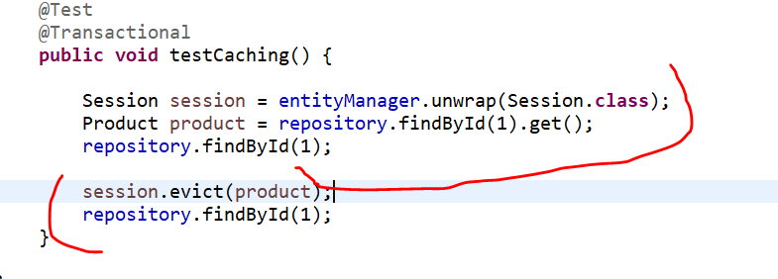

Here two select query will run



Now we are able to enable second level cache even after evict we will see only one select query

**EH Cache**

**Eh cache** : second level cache provider

We can save object both in ram and disk

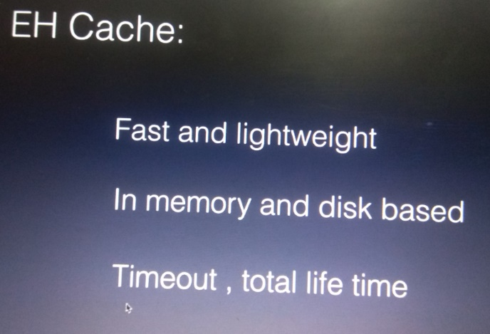

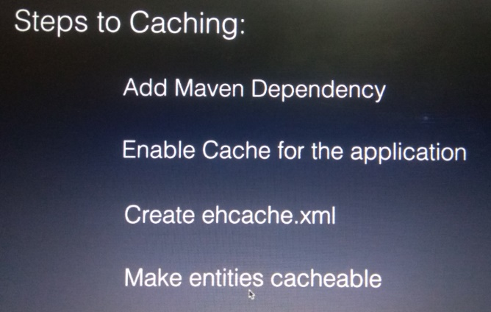

**Step 1 : add maven dependency for eh cache**

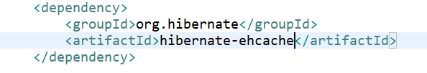

**Step 2 : configure cache through properties**

**sharedCache :** telling hibernate the cache should be shared across the session

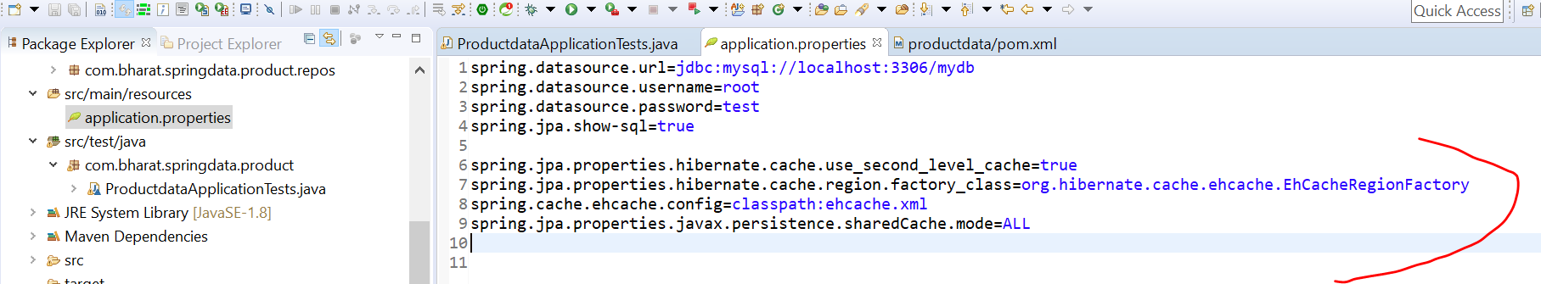

**Step 3 : create ehcache xml**

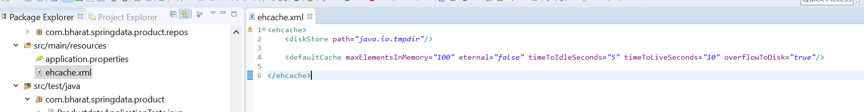

**Caching concurrency strategies**

We can select caching strategy in 4 ways

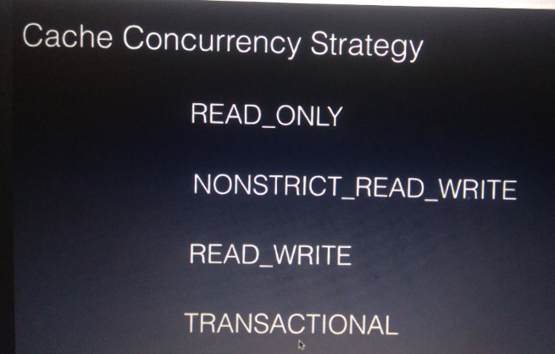

Note :

We should choose READ_ONLY only when entity in our application never change

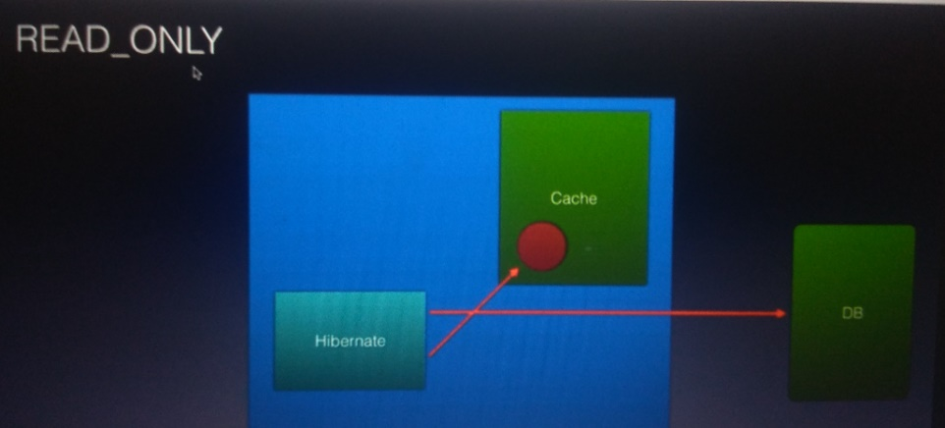

Will get stale data if transaction is not commit

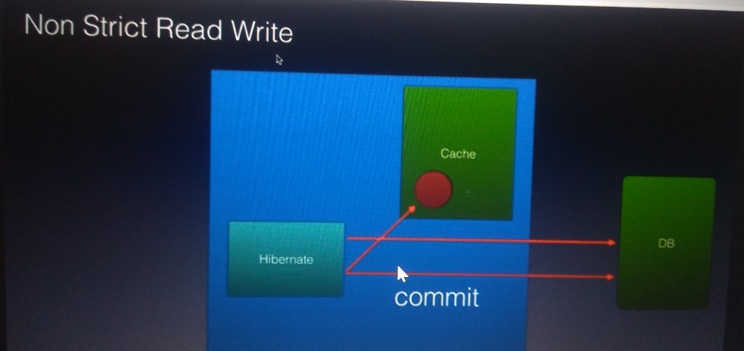

Total consistency we want then we should use read/write strategy :- if transaction is updating the data a soft lock is associated with a cache

Now another transaction want to access data it will see lock and it will directly access the d/b

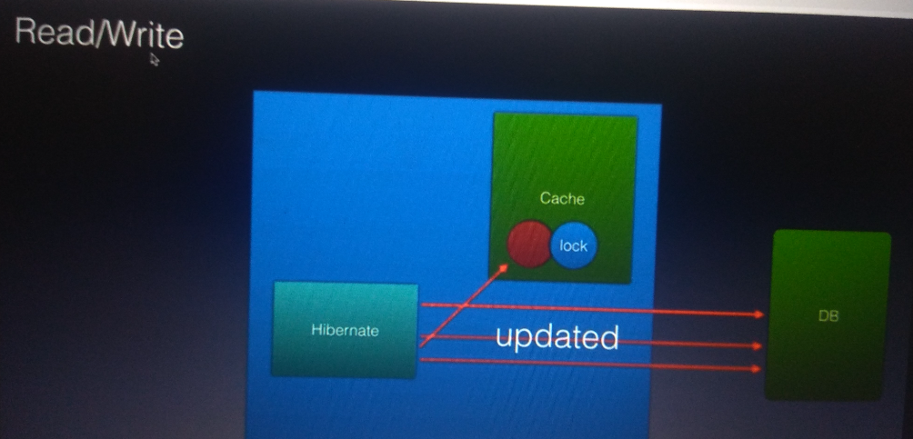

**Step 4:- Make entities cacheable**

As long as entity is is memory np but once object start writing in disk we need to implement Serializable

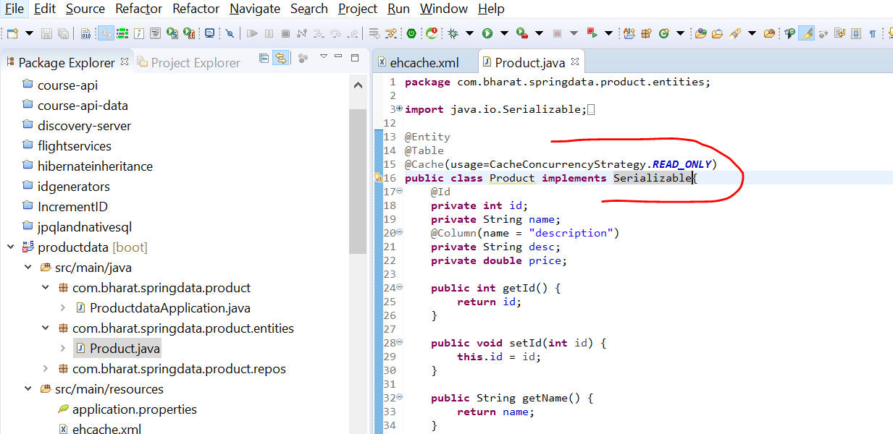

**Second level cache in action**

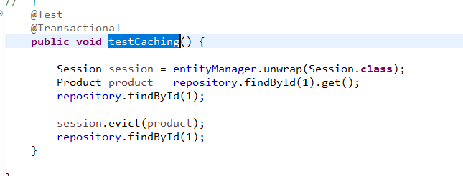

When it delete from first level cache then it will check second level cache

This time only one select query will execute



Section 16 transaction management

Introduction

Transaction is atomic unit of work in which all it happen or nothing it happen

**Use case**

Transferring 500 from obama account to trump account so we want both update to happen in single transaction

So will commit whole transaction and if any one update goes wrong will rollback whole transaction

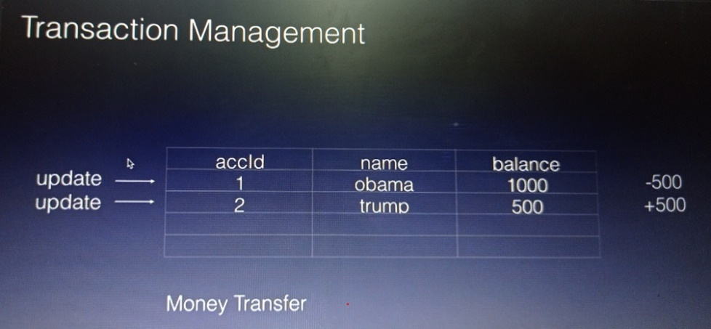

Every transaction has four key property also known as ACID property

**Atomicity** : either both update will happen or nothing will happen

**Consistency**: the d/b should left with consistency at the end of the transaction . The total balance should be consisted

**Isolation** : is there are multiple transaction happening each transaction should work independently without impacting each other

**Durability** : once the transaction changes committed those changes should stay in d/b

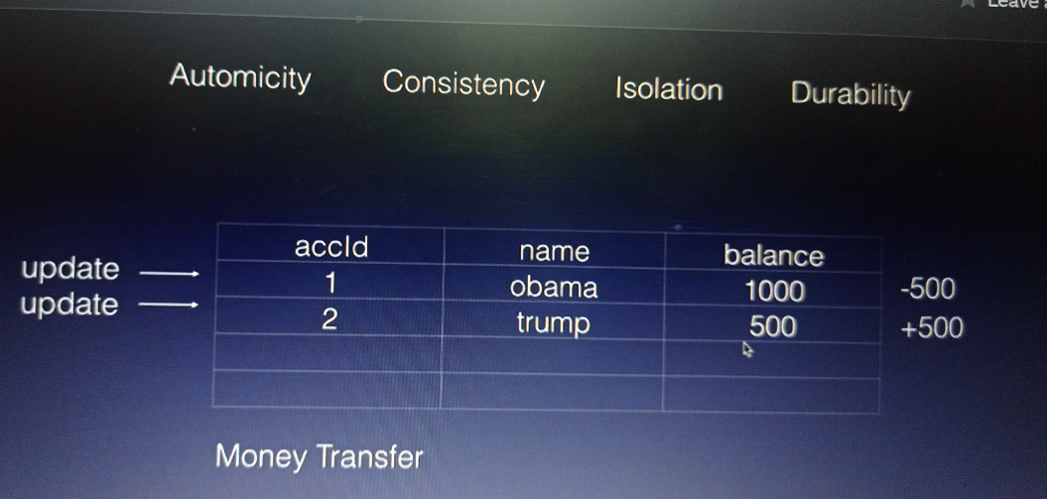

**Transaction management component**

Transaction app will perform commit and rollback through transaction manager which intern will use resource manager which knows

How to use api like jdbc, orm etc to perform transaction on underlying d/b.

If multiple d/b is running on diff server then it is called distributed transaction

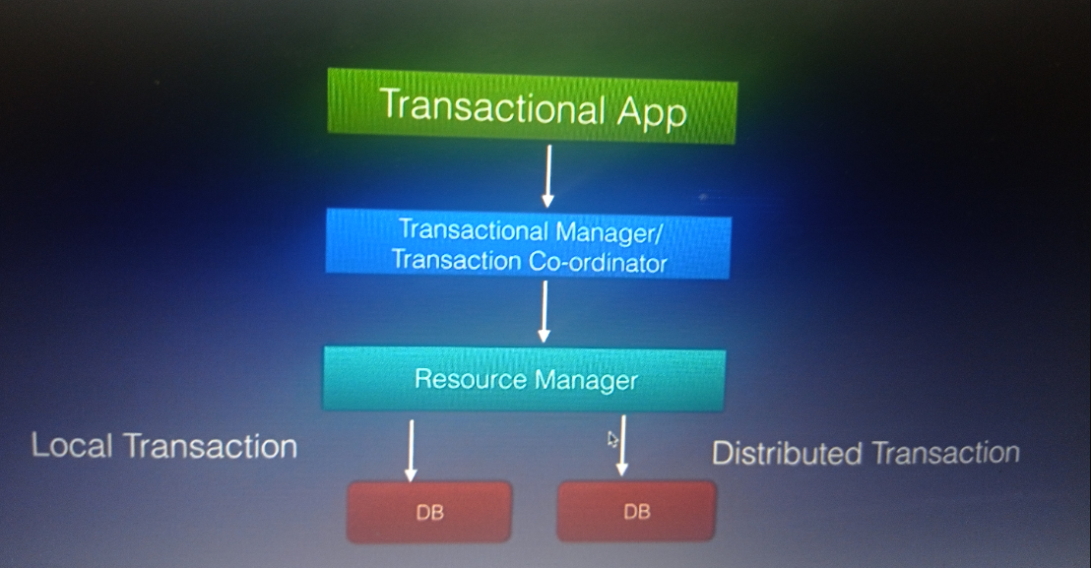

**Create the bank account table**

use mydb

create table bankaccount (accno int,lastname varchar(25),firstname varchar(25),bal int)

insert into bankaccount values(1,'obama','barack',5000)

insert into bankaccount values(2,'donald','trump',4000)

select * from bankaccount

drop table bankaccount

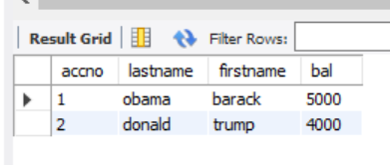

**Create the project**

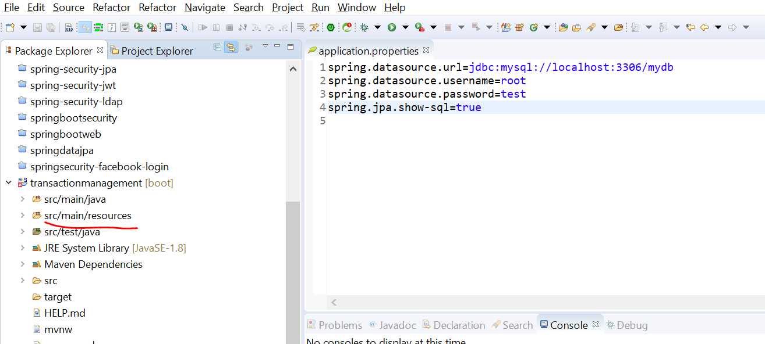

**Create the entity and repository classes**

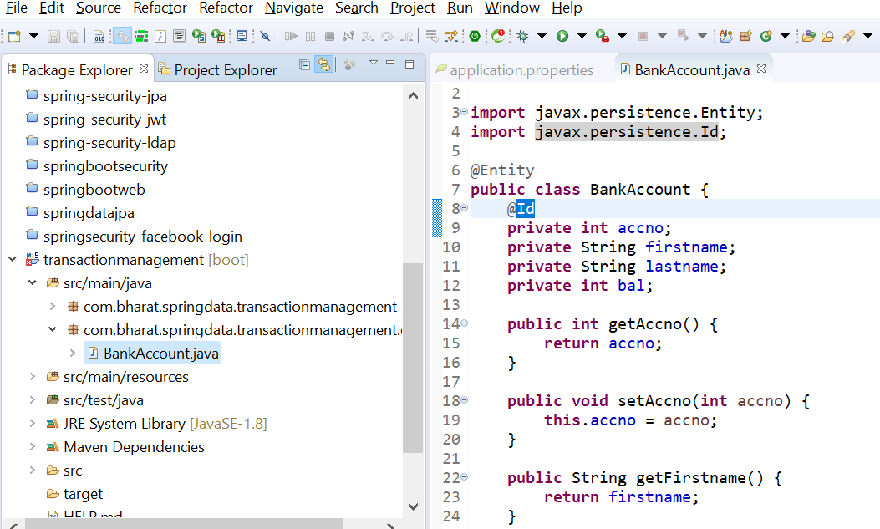

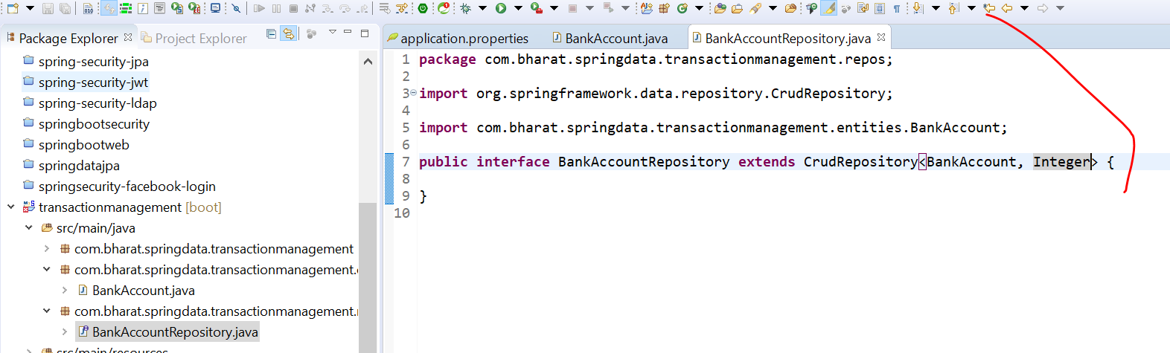

**Create the service layer**

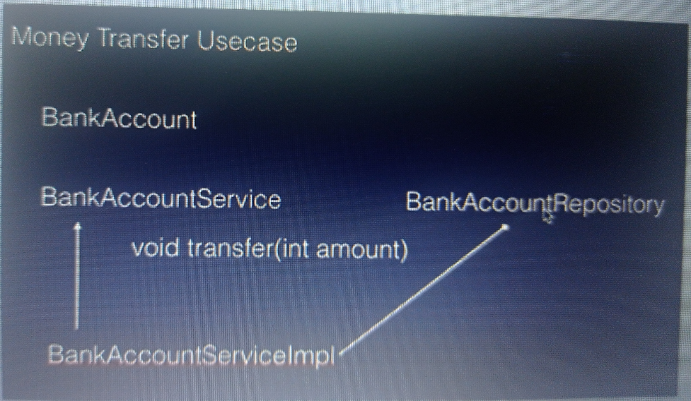

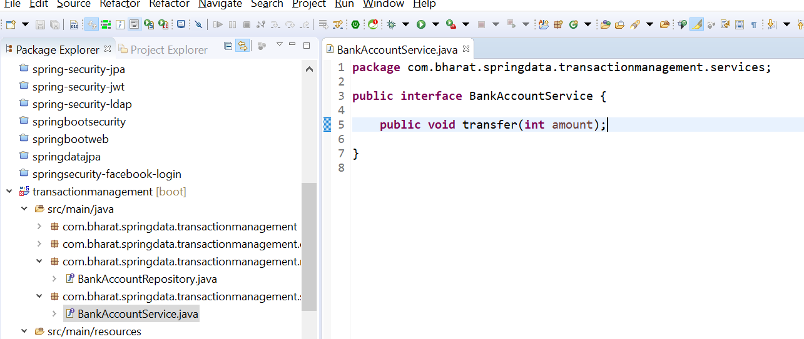

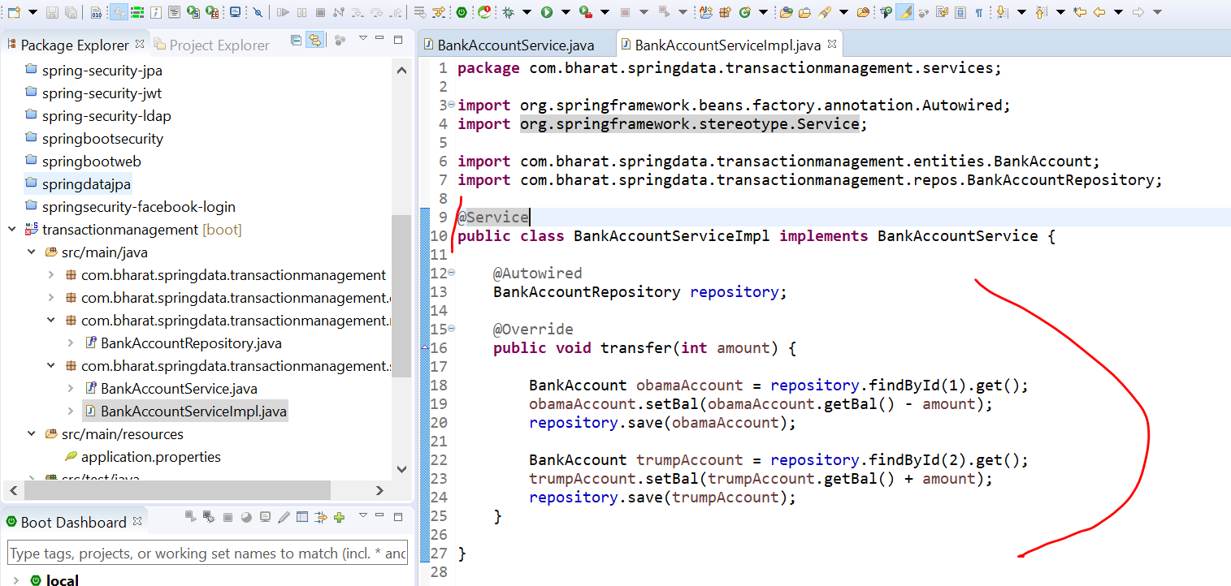

**Test the transfer method**

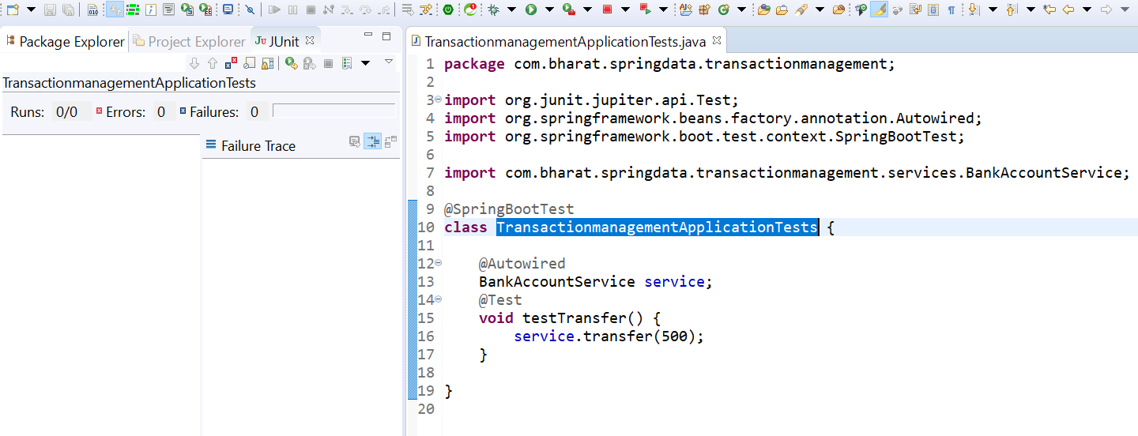

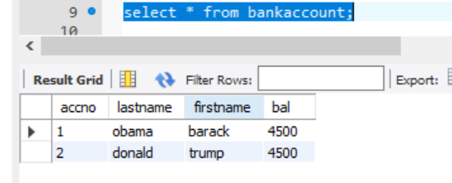

**Transaction in action**

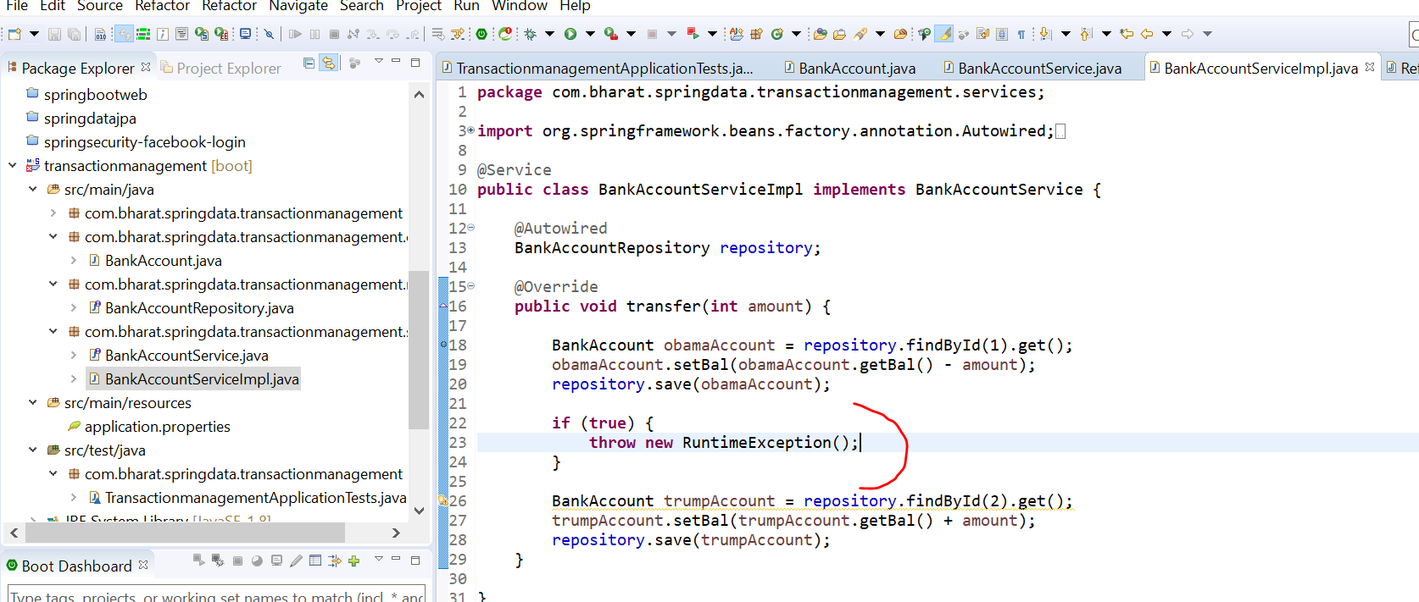

Only first will occur after running test case in second statement it will failed since exception is there

**Initially**

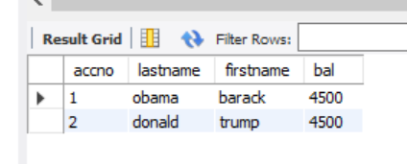

**After running test case**

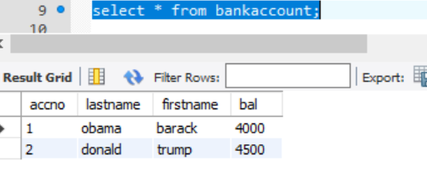

**From obama** account 500 gone that is where we need a transaction

We need to use @Transactional , once everything is committed otherwise it will roll back

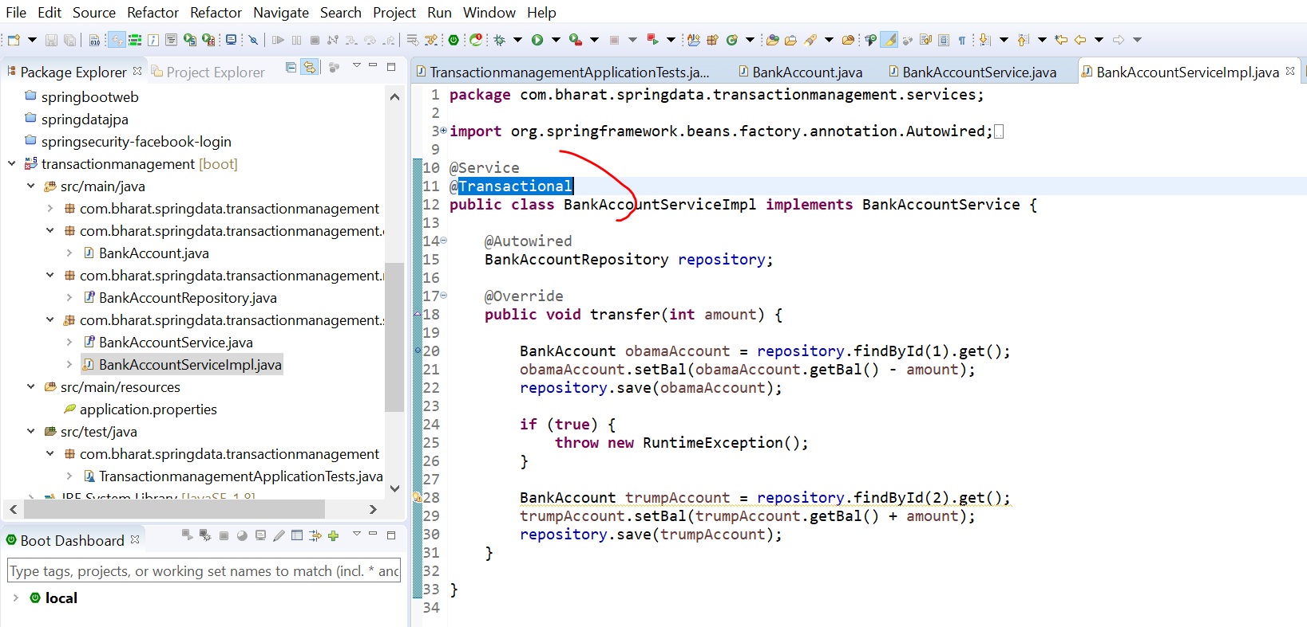

After running the test case the balance will remain the same



Section 17 save and retrieve file

Objective :

Save and read file from d/b table

The file will be represent in d/b using blob (binary large object)

We can store any type of file (like video, word) into this d/b column

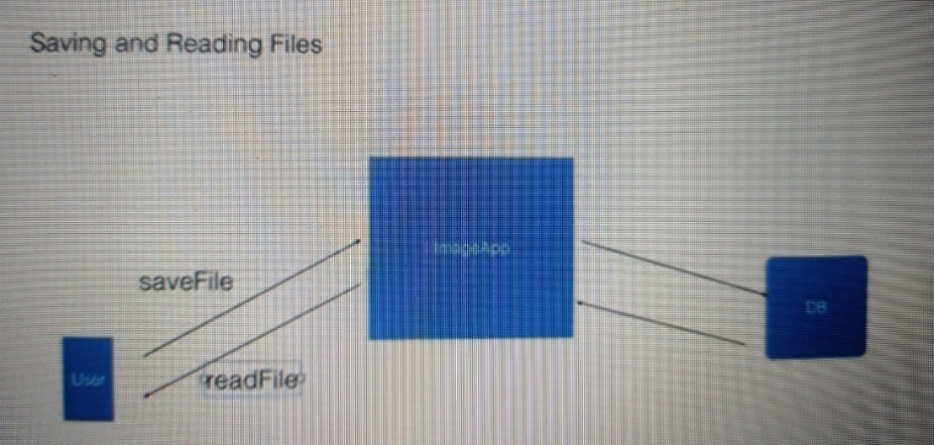

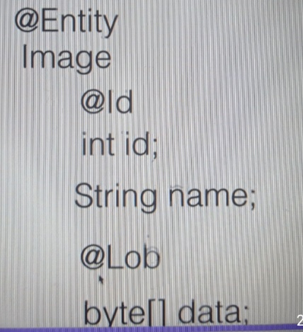

**Create the image table**

use mydb

create TABLE image(

id BIGINT NOT NULL,

name varchar(100) NOT NULL,

data BLOB NOT NULL,

PRIMARY KEY(id)

);

drop table image

**Create the project**

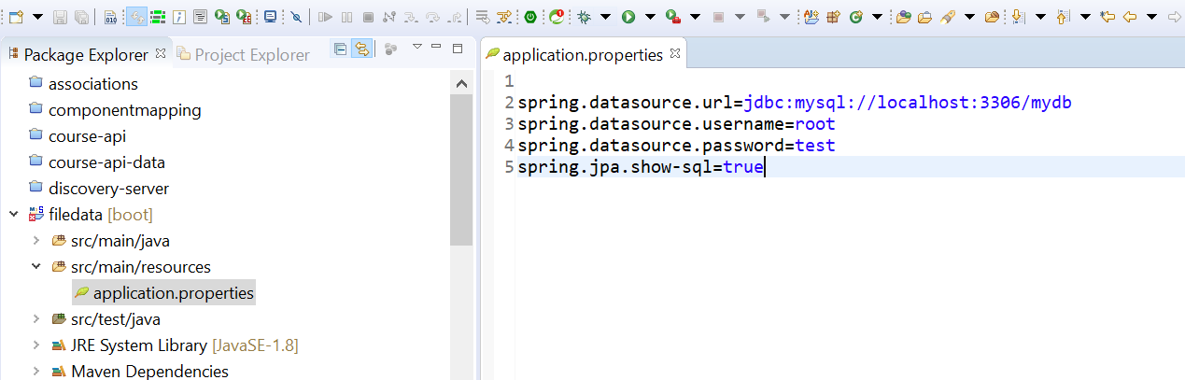

**Create the entity and repository**

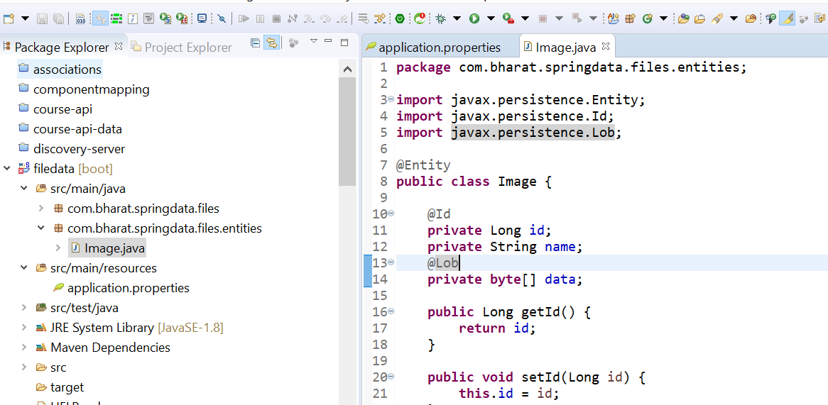

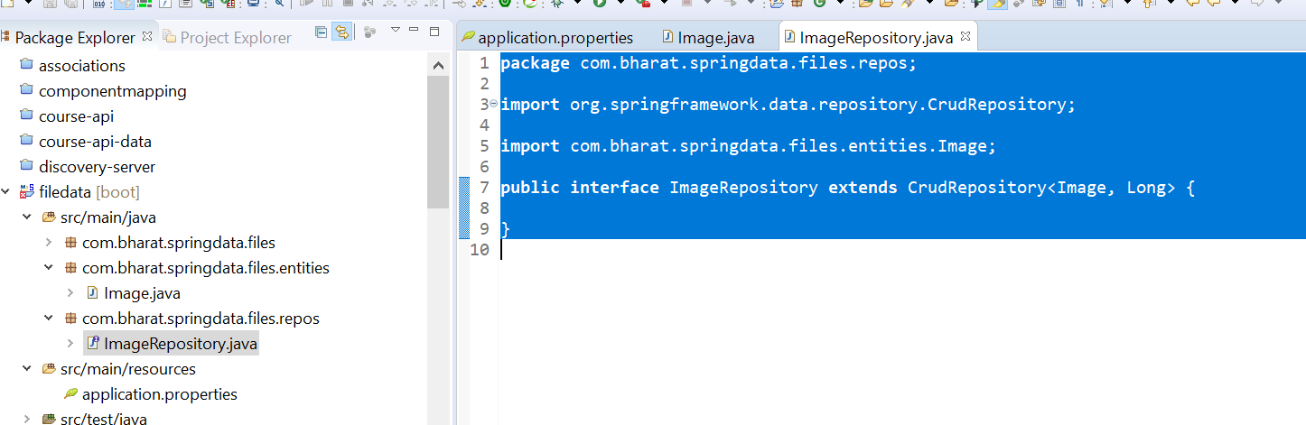

**Save the file**

Will open a file, read it into byte array and set it into data

inputStream will read the file and save it into file content

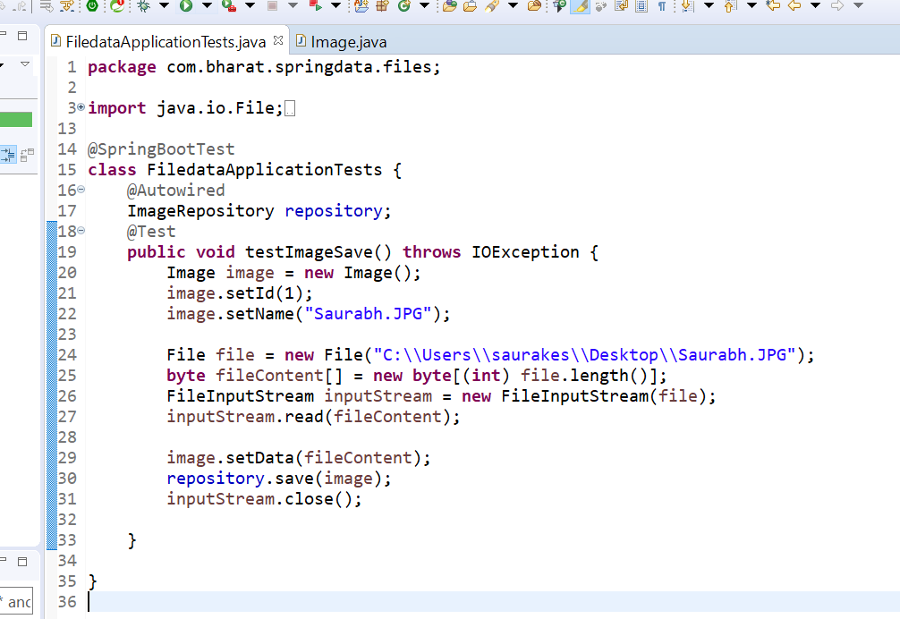

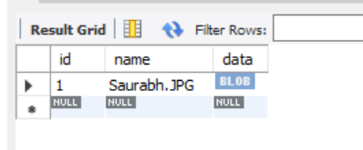

**Retrieve the file**

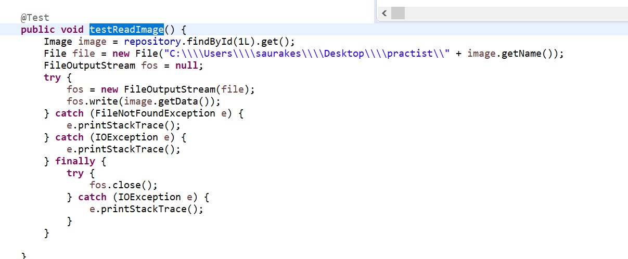

Section 18 calling stored procedure

Create stored procedure

select * from product;

DELIMITER //

CREATE PROCEDURE GetAllProducts()

BEGIN

SELECT * FROM product;

END //

DELIMITER //

CREATE PROCEDURE GetAllProductsByPrice(IN price_in decimal)

BEGIN

SELECT * FROM product where price>price_in;

END //

DELIMITER //

CREATE PROCEDURE GetAllProductsCountByPrice(IN price_in decimal)

BEGIN

SELECT count(*) FROM product where price>price_in;

END //

drop procedure GetAllProducts;

drop procedure GetAllProductsByPrice;

drop procedure GetAllProductsCountByPrice;

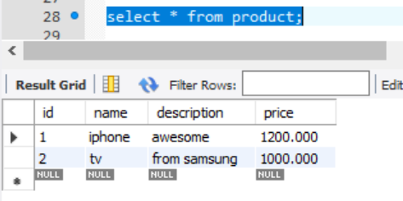

**Invoke with our params**

**Stored procedure call**

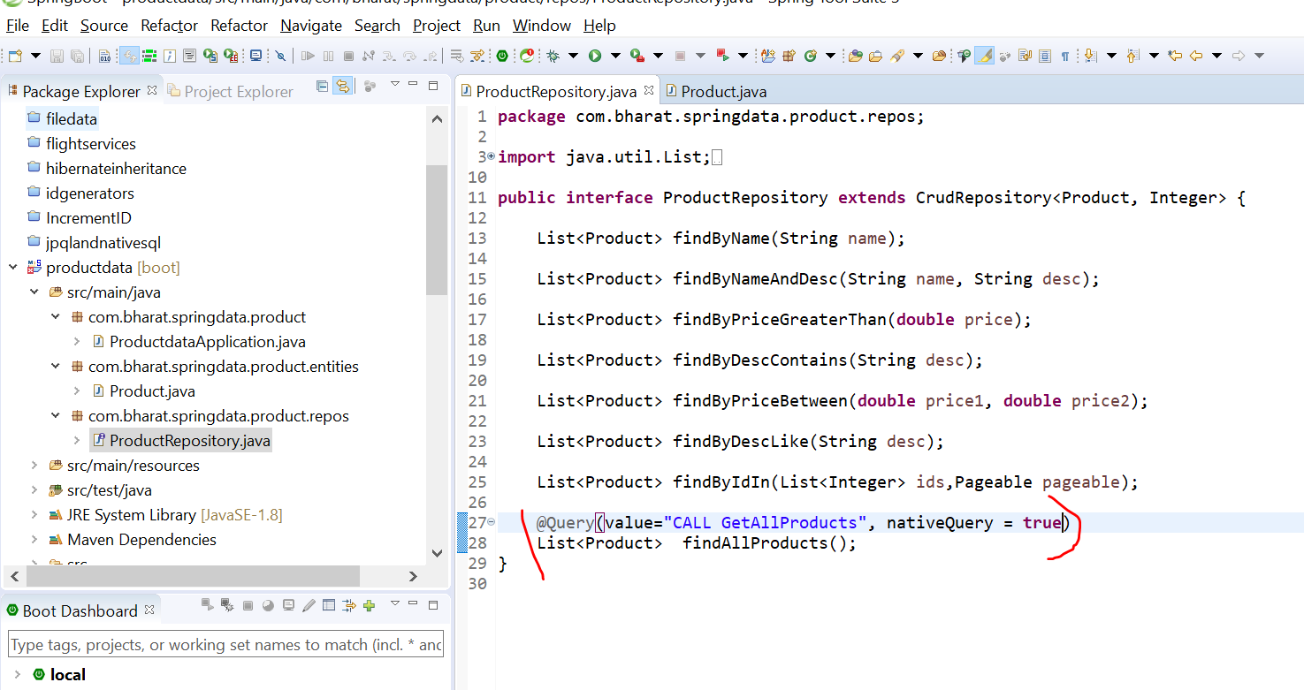

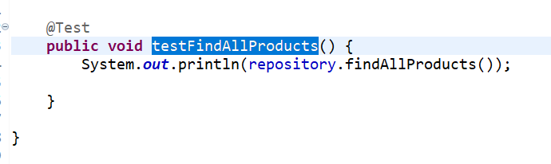



Section 19 end to end mini project

Patient appointment scheduling application

**Hospital reception** has the facility of checkin and checkout of patient

Appointment : has the patient checkin , check out

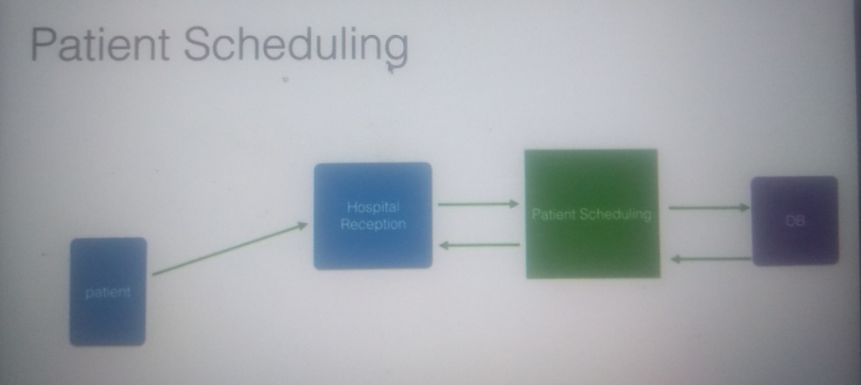

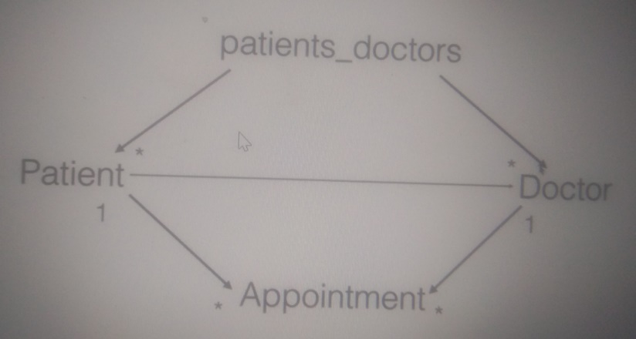

Create appointment

Create doctor

Create patient

**Create DB schema**

provider_name and copay is insurance info of patient

Note :

TinyInt : is numerical value if it is 0 it will consider as false and if it is any other value other than 0 it will be converted to true

use mydb

create table patient(

id int PRIMARY KEY AUTO_INCREMENT,

first_name varchar(20),

last_name varchar(30),

phone varchar(30),

provider_name varchar(30),

copay decimal(10,5)

)

create table doctor(

id int PRIMARY KEY AUTO_INCREMENT,

first_name varchar(20),

last_name varchar(30),

speciality varchar(30)

)

create table patients_doctors(

patient_id int,

doctor_id int,

FOREIGN KEY (patient_id)

REFERENCES patient(id),

FOREIGN KEY (doctor_id)

REFERENCES doctor(id)

)

create table appointment(

id int PRIMARY KEY AUTO_INCREMENT,

patient_id int,

doctor_id int,

appointment_time datetime,

started TINYINT(1),

ended TINYINT(1),

reason varchar(200),

FOREIGN KEY (patient_id)

REFERENCES patient(id),

FOREIGN KEY (doctor_id)

REFERENCES doctor(id)

)

select * from patient

select * from doctor

select * from appointment

select * from patients_doctors

drop table patients_doctors

drop table appointment

drop table patient

drop table doctor

**Create the patient scheduling project**

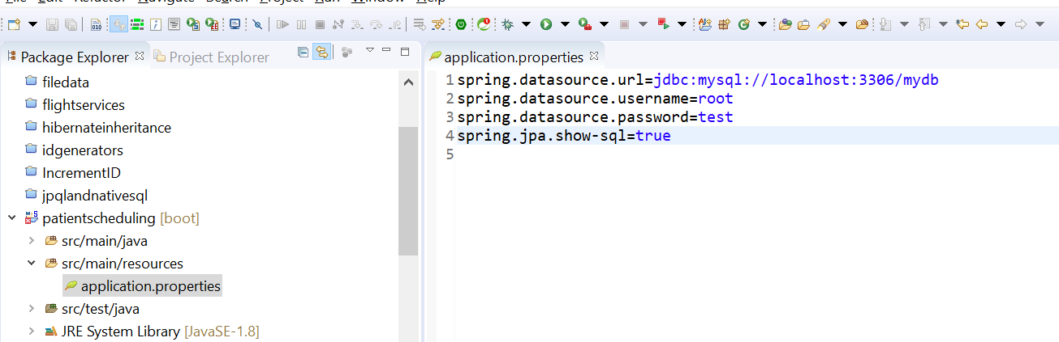

**Create entities**

**Patient_doctor :** is join table which will be use when we will define r/s b/w patient and doctor

We will use provider_name and copay in insurance

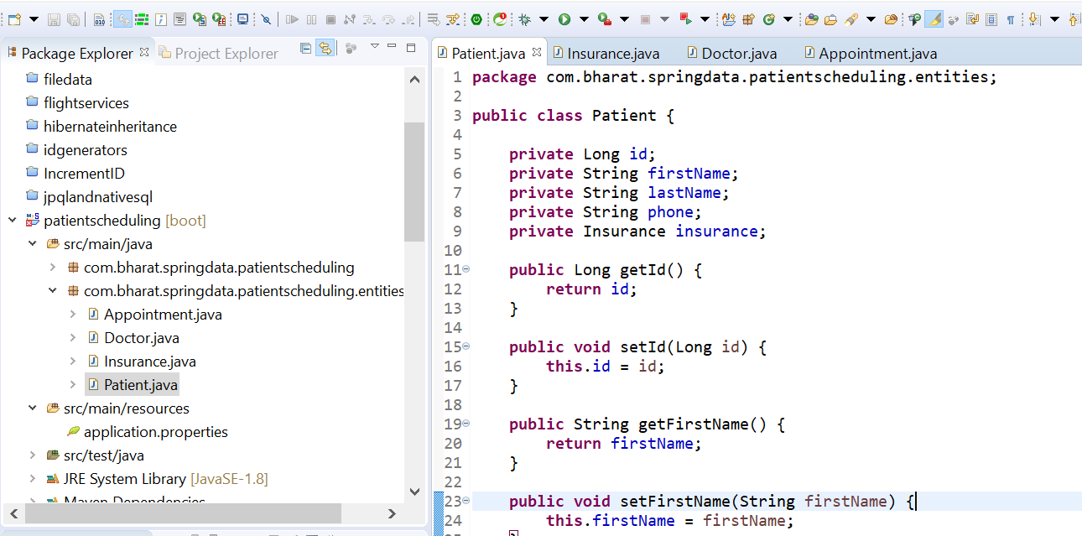

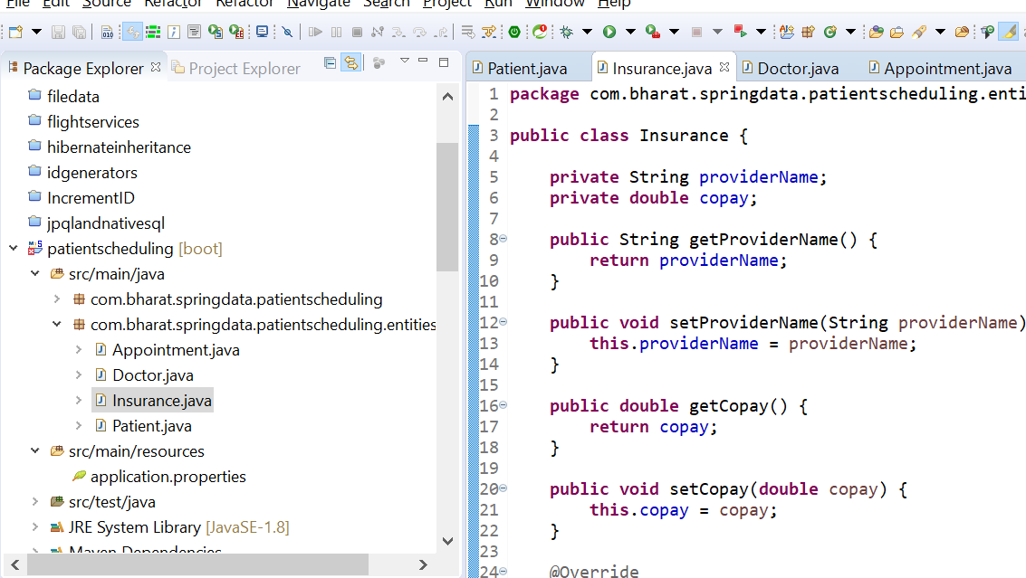

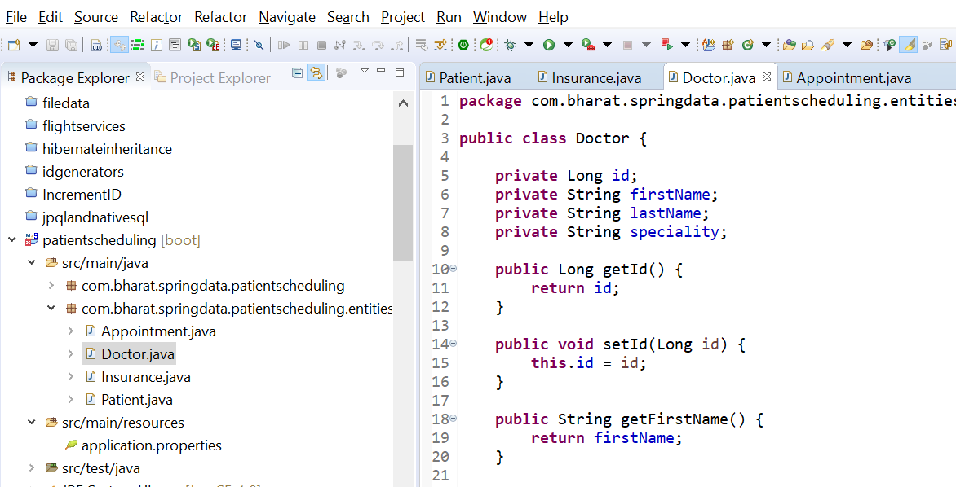

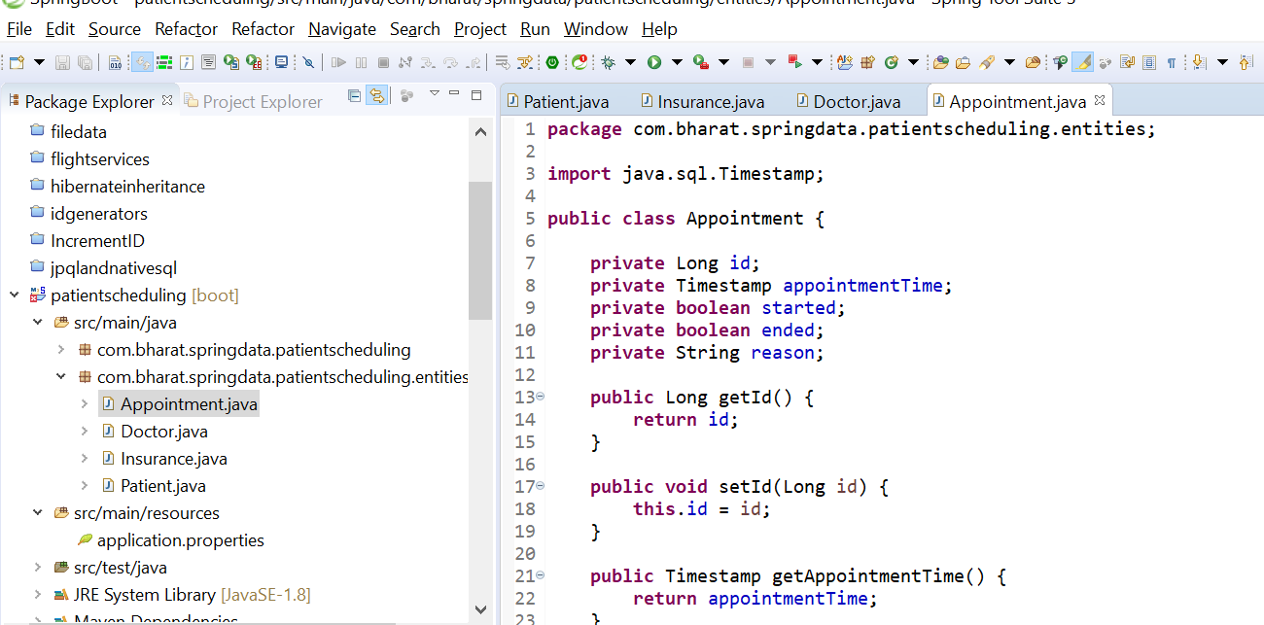

**Mark entities with JPA annotation**

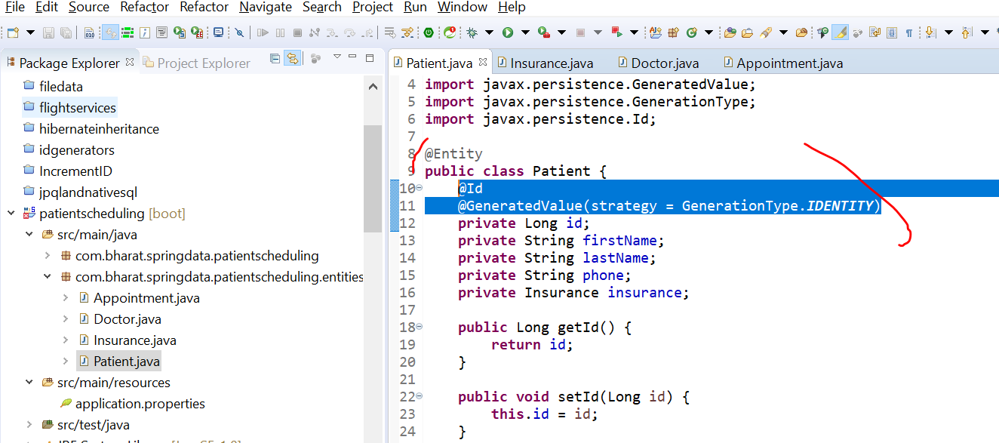

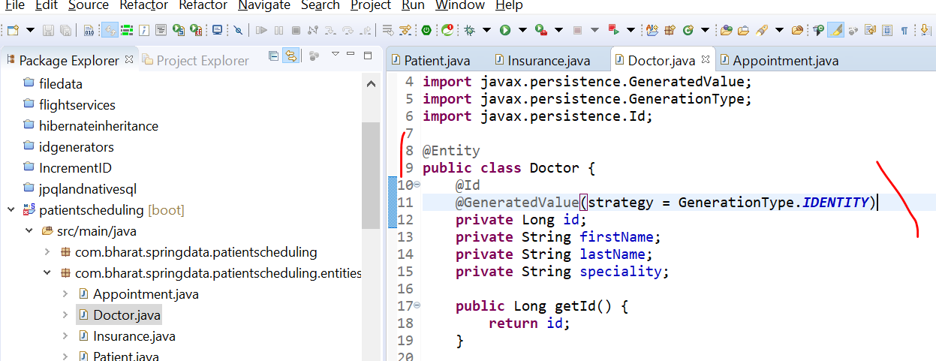

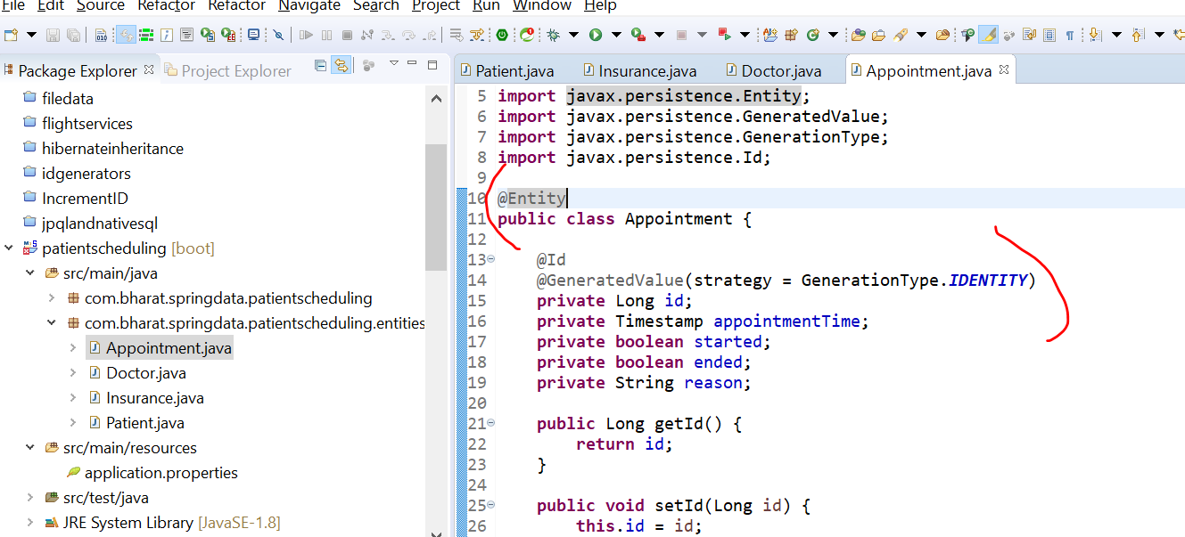

**Patients and insurance component mapping**

**Define association:**  component mapping b/w Patients and insurance

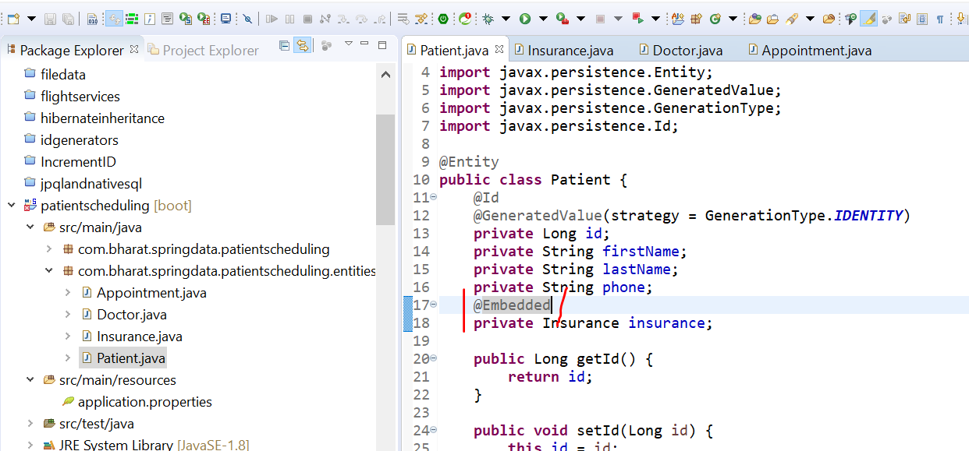

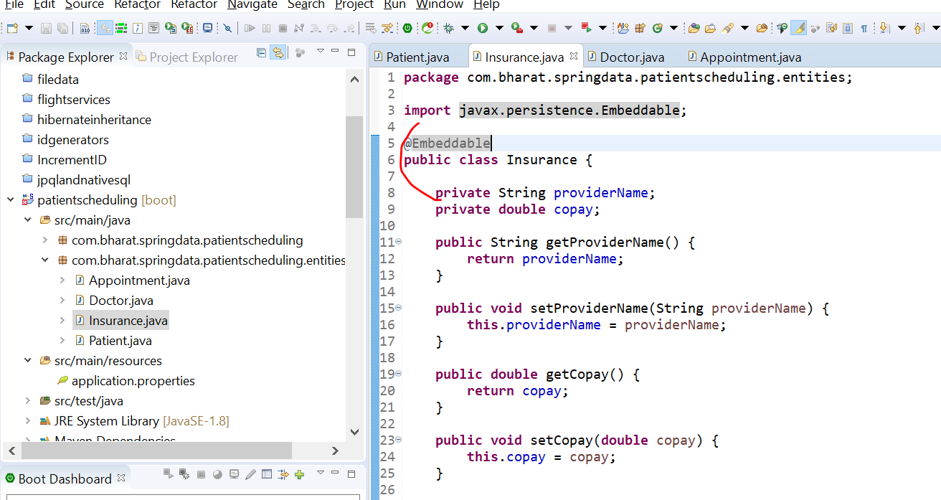

**Define the patient and doctor many to many association**

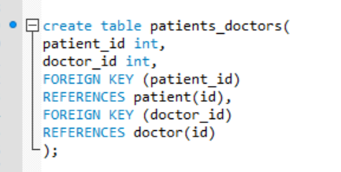

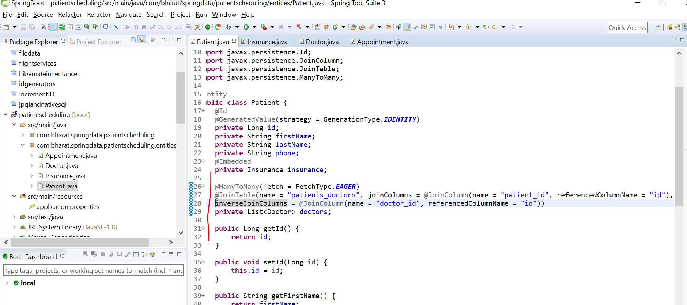

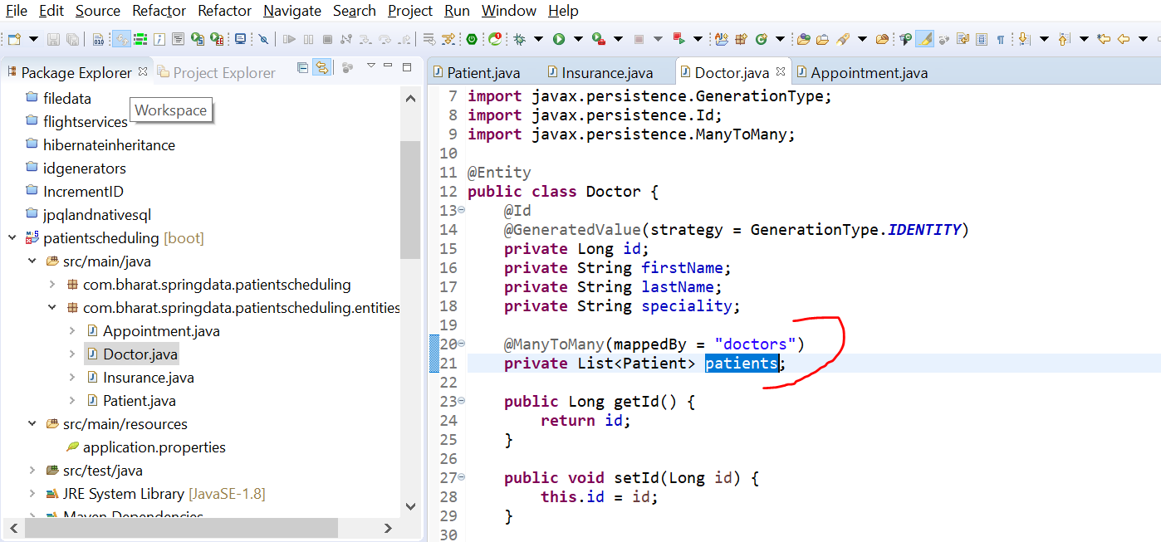

**Define the appointment relationship**

A patient can have multiple appointment and a doctor also can have multiple appointment

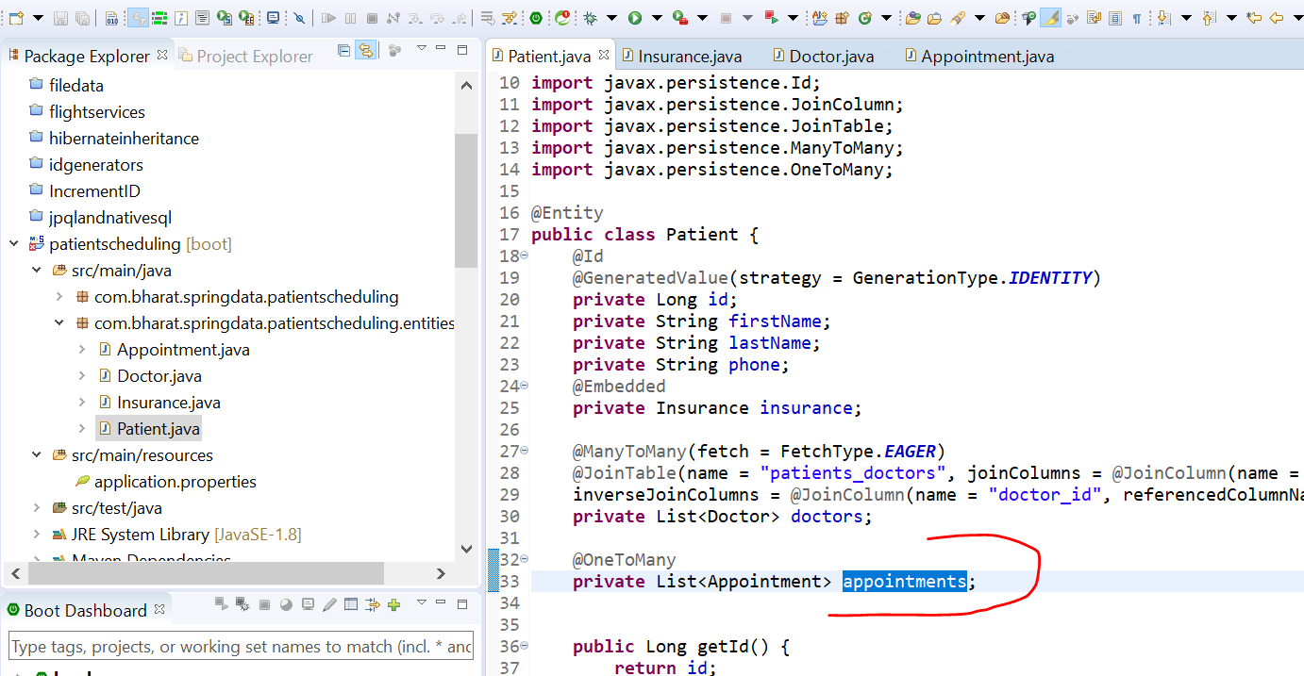

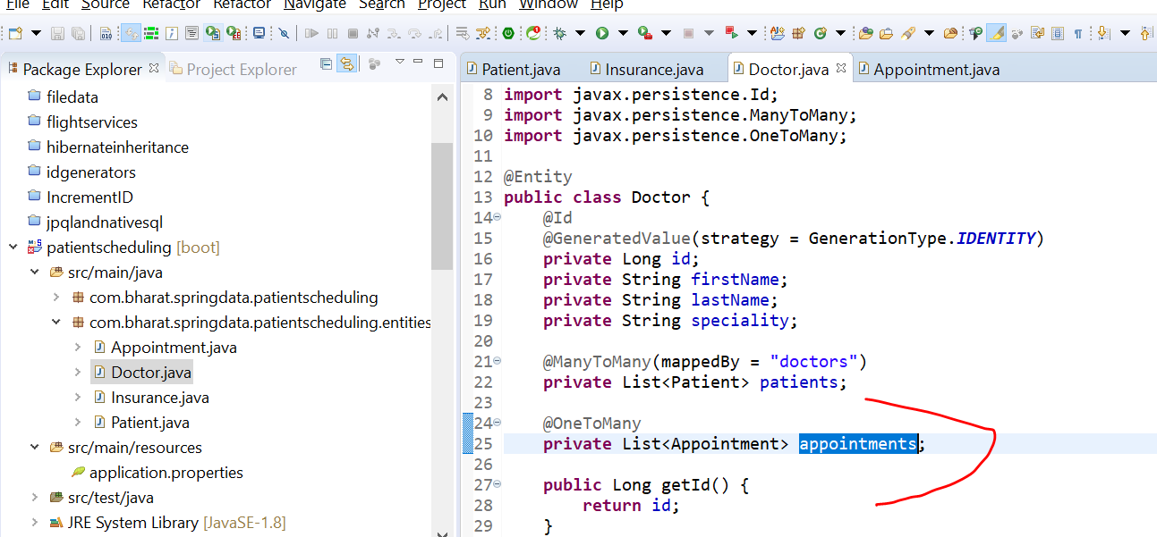

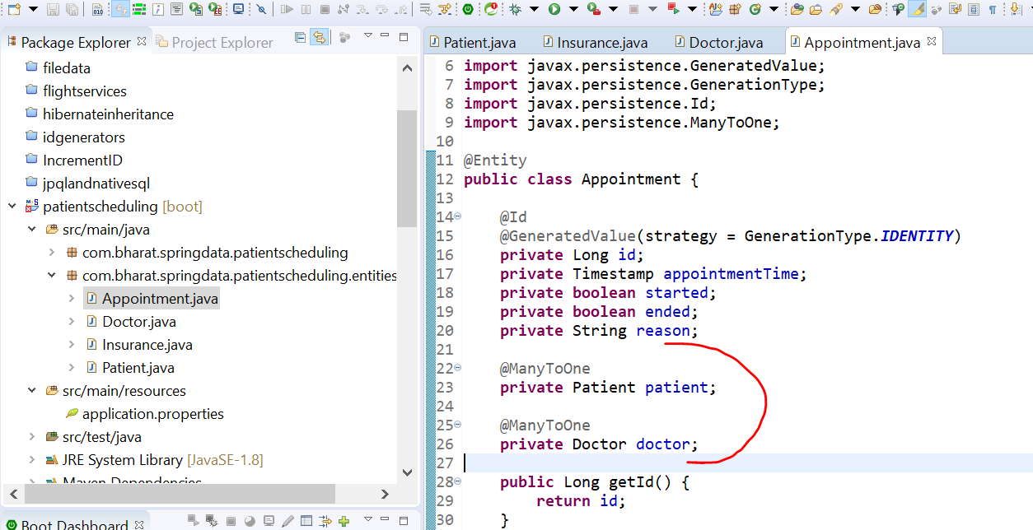

**Create repositories**

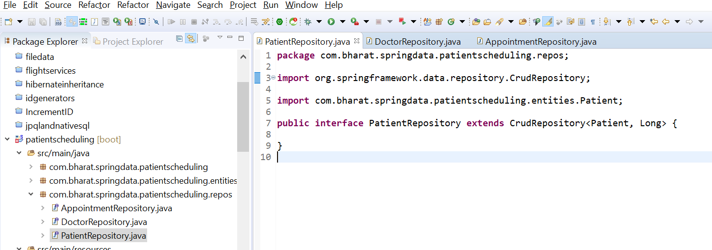

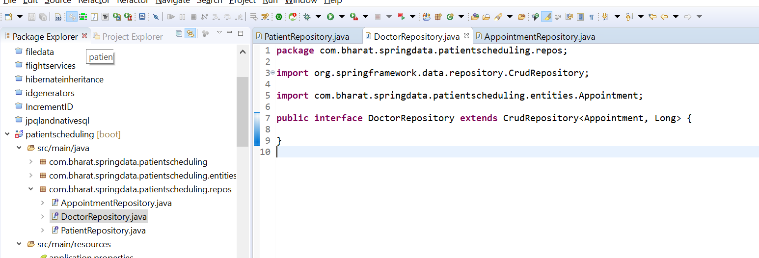

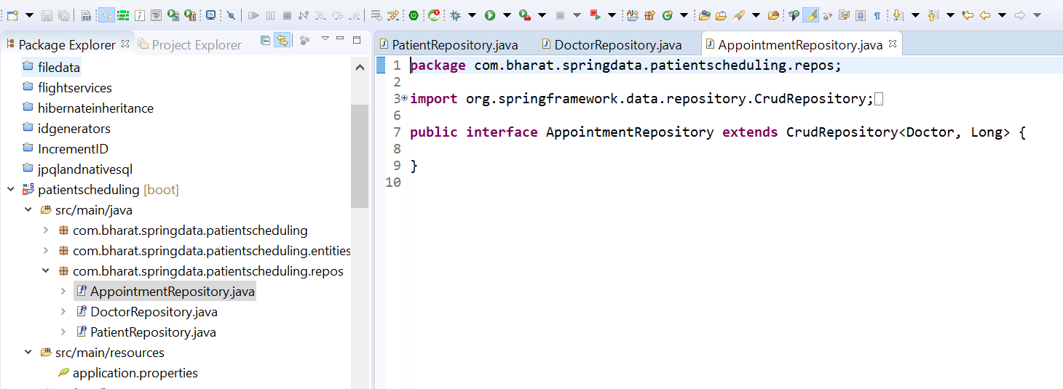

**Create doctor**

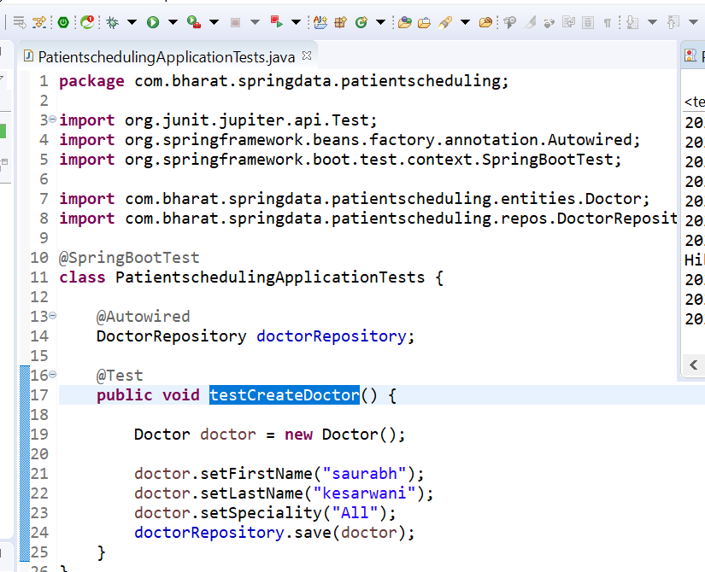

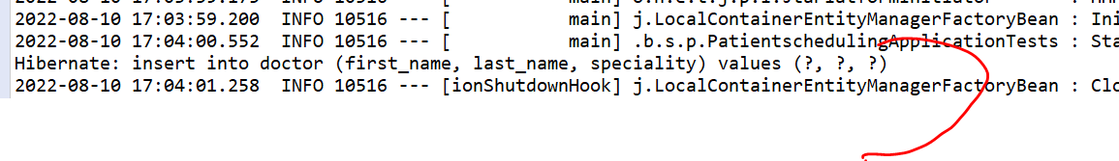

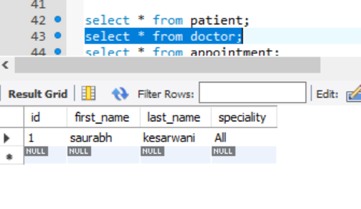

**Create patient**

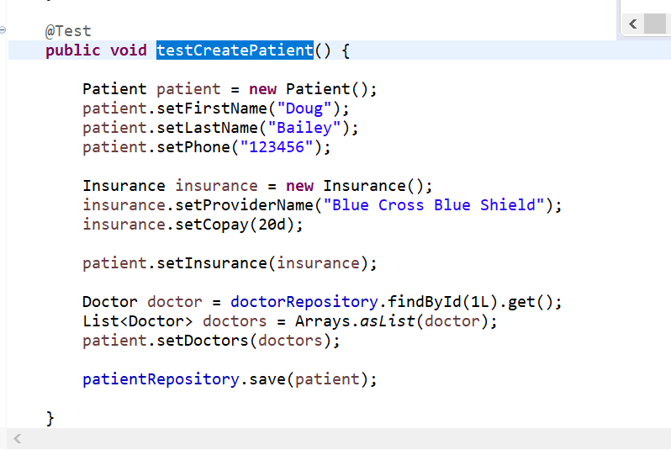

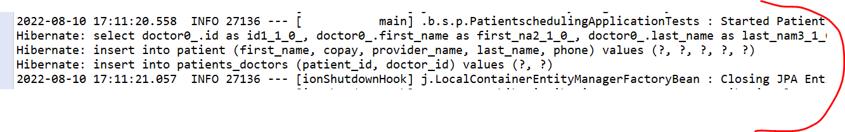

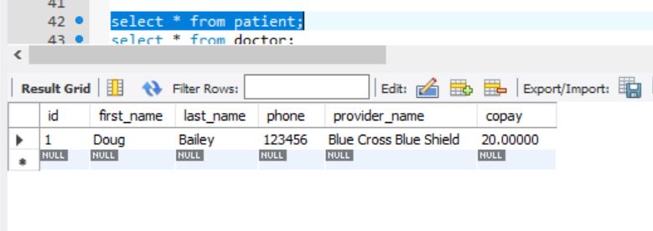

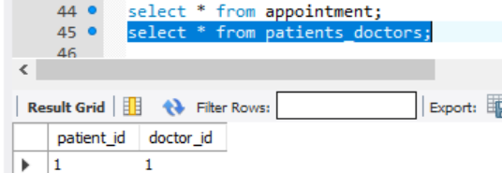

**Create appointment**

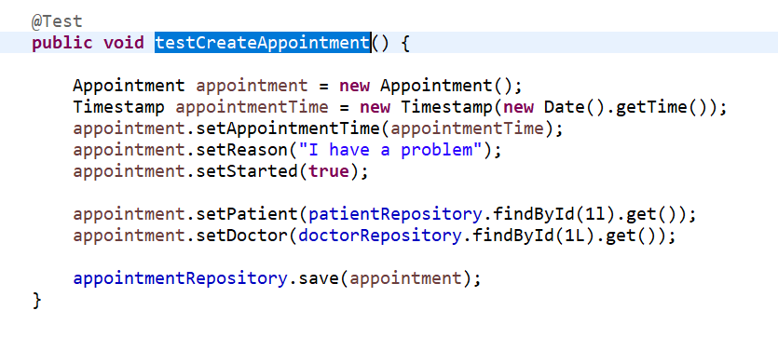



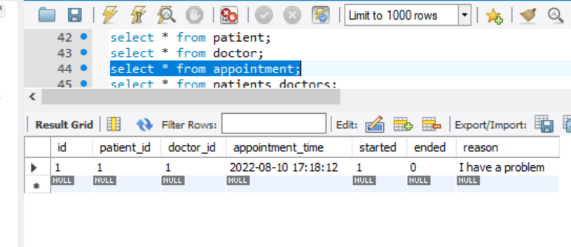

Section 20 composite primary keys

A composite key is combination of more than one d/b column

Requirement : id and email to be part of primary key

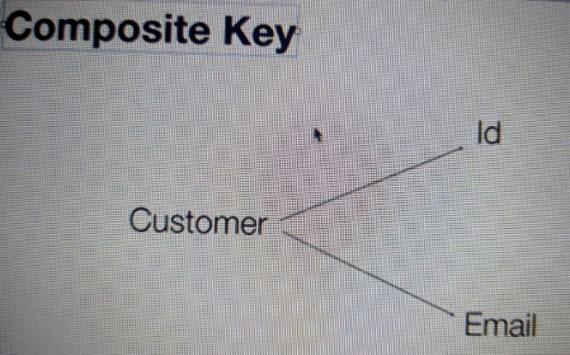

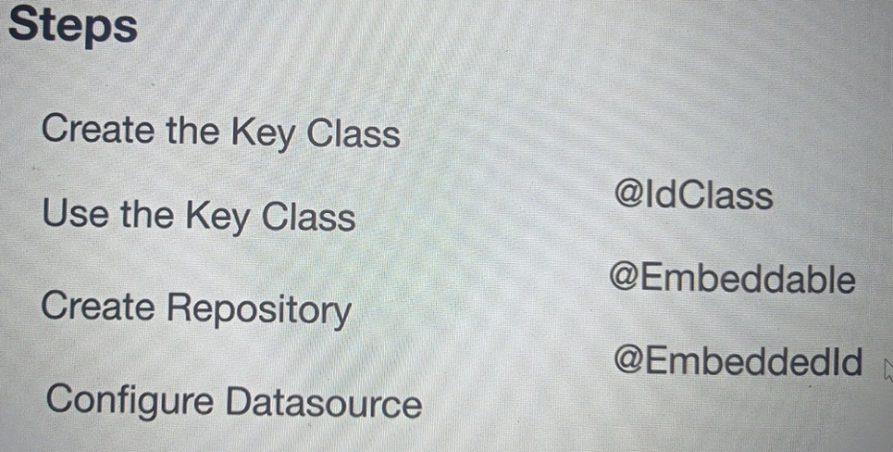

**Create customer table**

use mydb

CREATE TABLE customern (

id int NOT NULL ,

email varchar(255) NOT NULL,

name varchar(255) NOT NULL,

PRIMARY KEY (id,email)

);

select * from customer

drop table customer

**Create the key and entity classes**

Create the key class

Use the key class

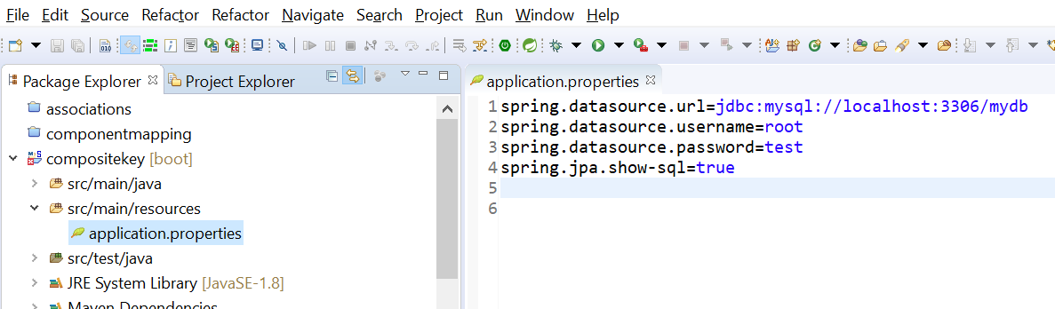

Every key class should implement serializable interface

Now we have composite key

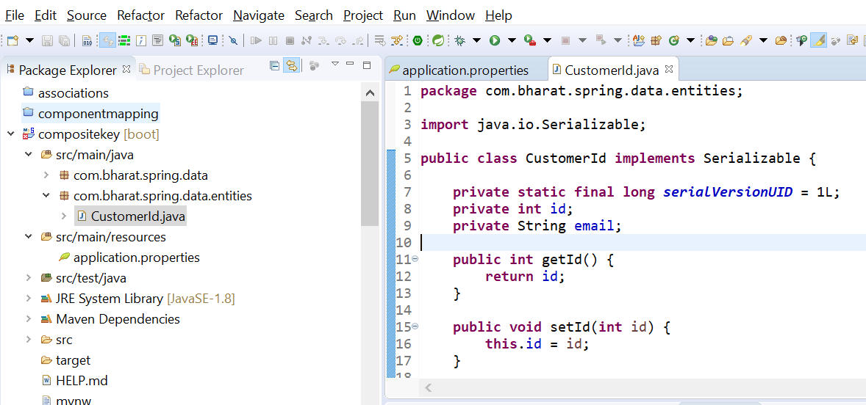

Using Idclass jpa will know about the composite class

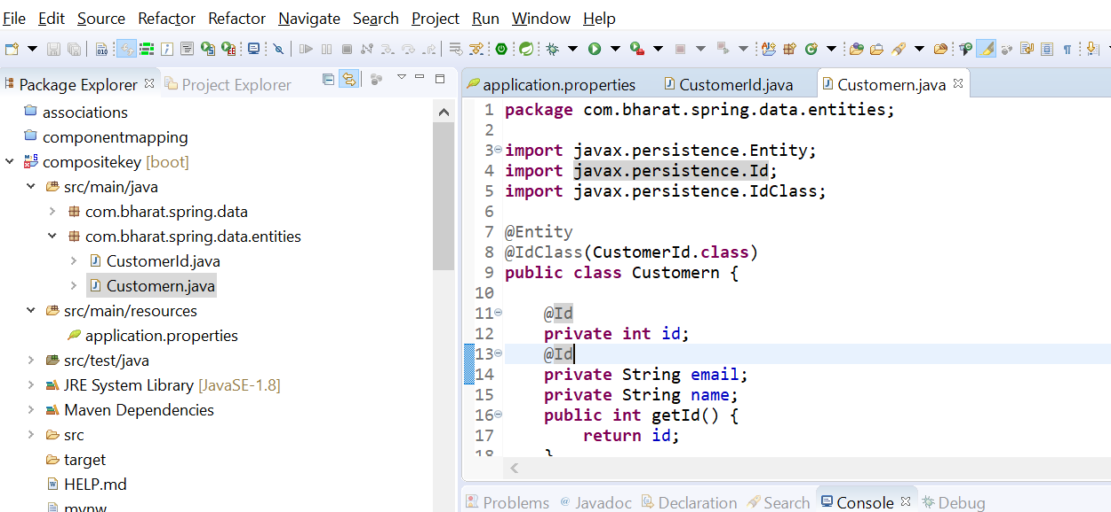

**Create repository and database configuration**

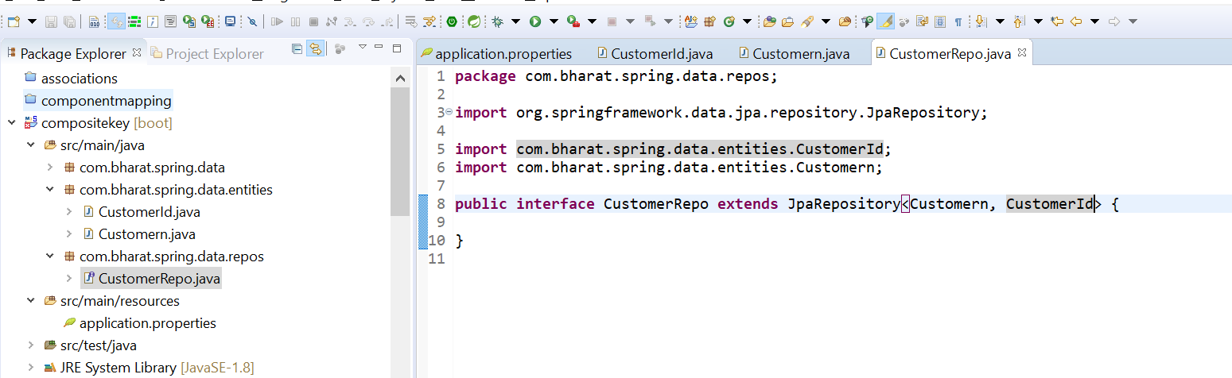

**Test**

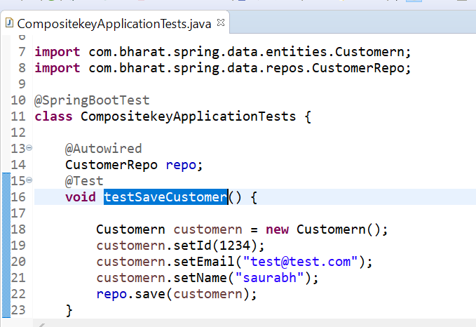

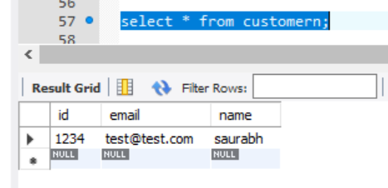

**Using embedded and embeddable**

**@Embeddable :** tell us this class can be embedded into any entity as a composite primary key class

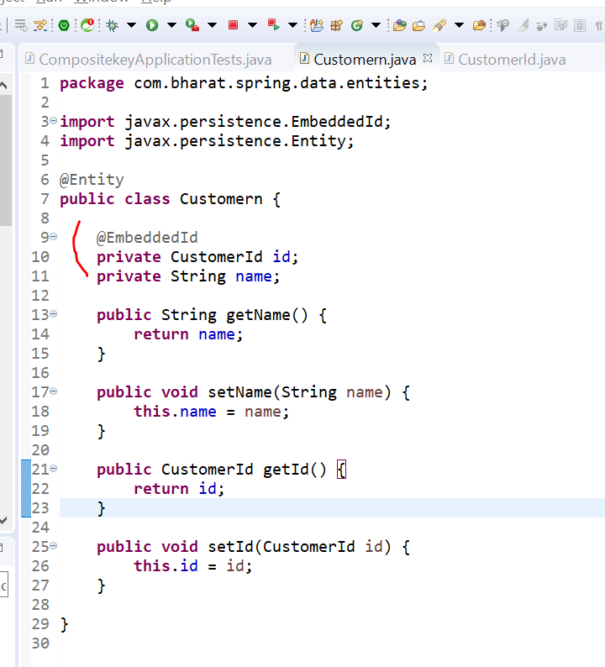

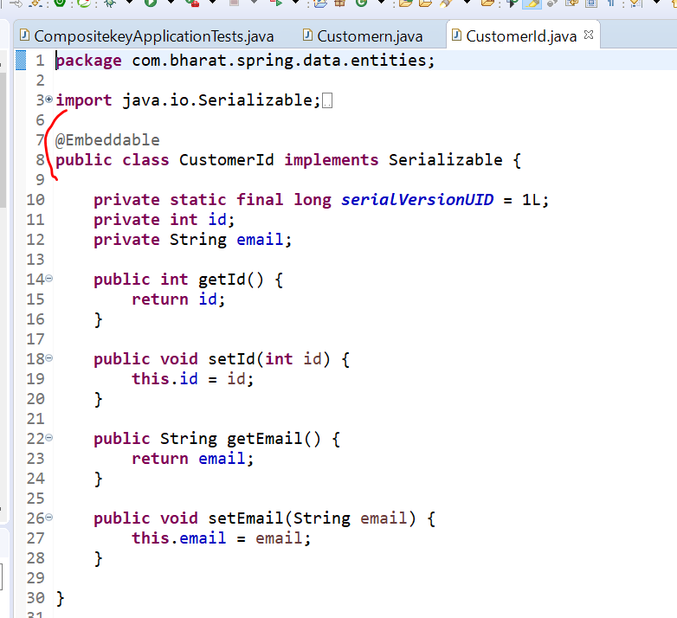

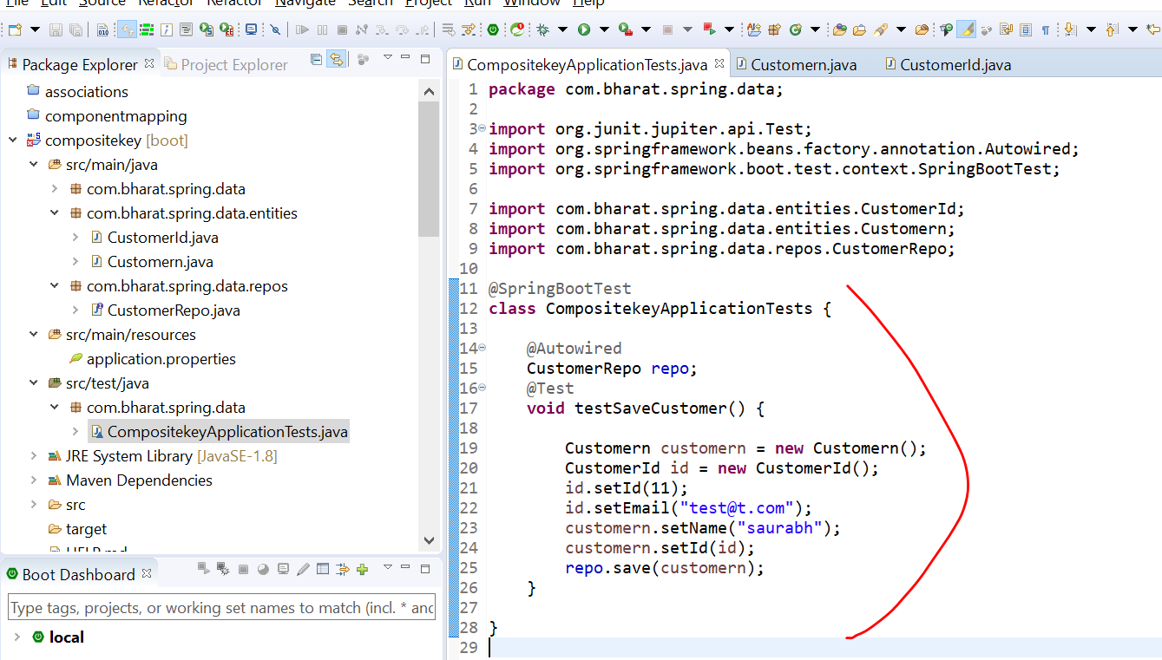

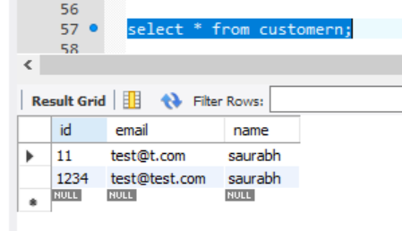

Section 22 deploy to aws